**Research Report**

**International Court of Justice**

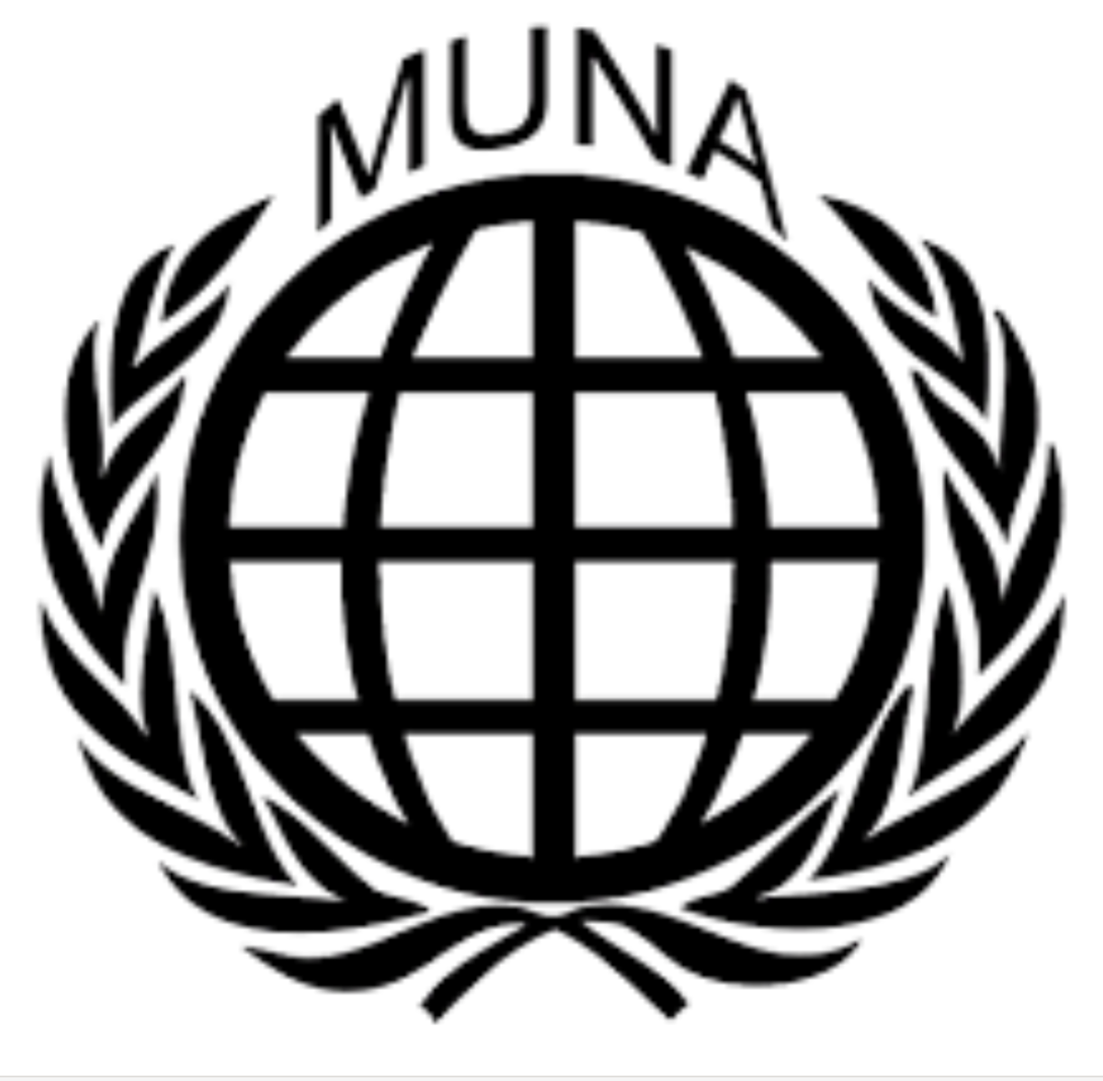

***Addressing the South China Sea Dispute***

*Student Officers:*

*Celine Lu and Lisa-Ling Scheermeijer*

**Introduction**

The Republic of the Philippines demands that the People Republic of China halt its activities and remove its installations from the South China Sea, especially within its Exclusive Economic Zone (EEZ). This dispute involves conflicting territorial claims, with the Republic of the Philippines citing United Nations Convention on the Law of the Sea (UNCLOS) and the People Republic of China asserting historical rights.

The South China Sea dispute involves conflicting territorial claims over maritime areas and islands in the region. This body of water holds immense strategic and economic importance, containing critical shipping routes, rich fishing grounds, and substantial oil and gas reserves. China’s expansive claim to the region, based on the "Nine-Dash Line," clashes with the territorial and maritime rights of several Southeast Asian countries.

The Association of Southeast Asian Nations (ASEAN) plays a mediatory role, advocating for a peaceful resolution through a Code of Conduct, but tensions persist as negotiations stall and unilateral actions continue.

**The committee**

​​The International Court of Justice (ICJ) is the United Nation’s principal judicial organ. The ICJ consists of the President of the ICJ, the Vice-President and the Head of Judges. These roles will be assigned to the student officers. The ICJ has jurisdiction over two types of cases: contentious (settling international legal disputes between states) and advisory (providing advisory opinions on inquiries of international law to certain UN organs and specialised agencies). The ICJ consists of 16 delegates, divided into eight judges and eight advocatess. A case consists of a dispute between two countries. Each country who is in conflict has an ally country, totalling to four advocates representing each side. The other eight delegates act as judges. Bear in mind that the judges should act impartially. Each delegate will take the role of a judge and an advocate twice. During the conference, the ICJ will discuss two cases per day totalling up to four cases. For each case, there is a followed process consisting of four stages:

1. All countries have to merge the charges they prepared into one and write an **opening statement**. At the start of each case, both parties involved in the dispute have to give their opening statement. In the opening statement the advocate will read their charge to the judges and explain their charge.

2. After the opening statements, the first part of the debate will commence. This starts as an **open debate** and has a time limit. Both countries can attack the others’ charge and support their own. The judges can also ask each country to clarify clauses in their charges, or the charge as a whole.

3. Proceeding the open debate, the debate will continue as a **closed debate**, which also has a time limit. For both charges, there will be time in favour and time against. It is required for each country to speak at least once in favour of their charge, and at least once against the other charge.

4. After the closed debate, the ICJ will move into **voting procedures**, the charge of the accusing country will be voted on.

**Keywords**

United Nations Conventions on the Law of the Sea (UNCLOS): The United Nations Convention on the Law of the Sea is established in 1982 and lays down a comprehensive regime of law and order in the world's oceans and seas. Establishing rules governing all uses of the oceans and their resources.

The Association of Southeast Asian Nations (ASEAN): The Association of Southeast Asian Nations aims to promote economic and security cooperation among its ten members: Brunei, Cambodia, Indonesia, Laos, Malaysia, Myanmar, the Philippines, Singapore, Thailand, and Vietnam.

Exclusive Economic Zone (EEZ): a sea zone prescribed by the United Nations Convention on the Law of the Sea (UNCLOS) that allows a coastal state special rights regarding the exploration and use of marine resources, including energy production from water and wind.

Nine-dash line: a demarcation used by China to claim most of the South China Sea. This claim is disputed by the other ASEAN member states.

**Arguments**

China

1. China claims historical rights over most of the South China Sea, citing maps dating back to the 1940s. The "Nine-Dash Line" encompasses nearly 90% of the sea, including islands like the Spratly islands and Paracels. China has undertaken large-scale land reclamation, turning reefs into artificial islands equipped with military infrastructure, which escalates tensions.
2. China refused to participate in the proceedings, asserting that the tribunal had no jurisdiction and that it maintained “historic rights” in the South China Sea. In its **2014 position paper,** China argued that the dispute involved sovereignty claims, which UNCLOS does not adjudicate.

The Philippines

1. The Philippines challenges China’s claims and asserts sovereignty over parts of the Spratly and Paracel Islands. Using international law, particularly the United Nations Convention on the Law of the Sea (UNCLOS), to argue for its rights within its Exclusive Economic Zone (EEZ).
2. The Philippines sought clarification on the maritime status of features like Scarborough Shoal, Mischief Reef, and Second Thomas Shoal, arguing they were rocks or low-tide elevations incapable of generating exclusive economic zones (EEZs) or continental shelves.
3. The Philippines accused China of interfering with fishing rights, violating its sovereignty, and causing environmental damage through activities like large-scale land reclamation and artificial island construction.

**Timeline of events**

* August 8th, 1967 – Establishment of ASEAN.
* *December 10th, 1982* – UNCLOS is established.
* *January, 1906* – Mischief reef incident: A 90-minute battle between the Chinese and Philippine navy.
* *November, 2002* – China and the other ASEAN states reach an agreement on the Declaration on the Conduct of Parties in the South China Sea.
* *March - June, 2011* – The Philippines demands the presence of a Chinese envoy to express its increasing concern about naval incursions in Philippine claimed territory.
* *October, 2011* – The Philippines renames the South China Sea to the West Philippine Sea.
* April 8th, 2012 – The Philippines dispatches a warship to confront Chinese fish boats in Scarborough Shoal.
* *July 13th, 2012* – ASEAN fails to issue a communiqué on how to deal with China’s claims on disputed territory in the South China Sea/ West Philippine Sea.
* *January 22nd, 2013* – The Philippines initiates an international arbitration case regarding the Chinese claims of sovereignty over Spratly Islands and Scarborough Shoal. China rejects the process.
* *January, 2014* – China imposes a fishing permit rule in the South China Sea/West Philippine Sea.
* *March 11th, 2014* – Two Philippine ships are barred by the Chinese navy from the Spratly Islands.
* July 12th, 2016 – The Permanent Court of Arbitration rules in favour of the Philippines.
* *August 28th, 2023* – China expanded its territorial claims map, which includes an extra dash added to the previous nine-dash line.
* *November 8th, 2024* – the Philippines Maritime Zones Act

**Resolution**

To address this issue, it is essential to draft a solution that aims to resolve the ongoing dispute between the Philippines and China. Bear in mind that as a delegate, you represent your country’s official stance on this issue. Consider your countries norms and interests rather than your personal ideas and values. The resolution should reflect your country’s perspective based on economic, political, cultural, and ethical factors. If your country is not immediately affected by this issue, research the perspectives of your allied nations to understand their stance on the dispute, so you know which resolutions to help with and vote on. Furthermore, your resolution must also include possible solutions which are clearly elaborated and when needed examples are used. For extra information on resolution-writing and the guidelines, visit the MUNA website and read the ‘MUNA Instruction Booklet’<https://munalfrink.nl/conference/downloads/>

**Links and resources**

<https://www.cfr.org/timeline/chinas-maritime-disputes>

<https://pca-cpa.org/en/cases/7/>

<https://pcacases.com/web/sendAttach/1801>

<https://www.cfr.org/councilofcouncils/global-memos/hague-tribunals-south-china-sea-ruling-empty-provocation-or-slow-burning-influence>

<https://www.mfa.gov.cn/eng/zy/gb/202405/t20240531_11367334.html>