**RULES OF PROCEDURE**

**Historical Committee**

**Anything that is not discussed in this booklet, such as Modes of Address, are discussed in the MUNA booklet and will not be treated differently in the Historical Committee.**

**The Committee**

The Historical Committee, consisting of a total of 18 delegates representing 9 great powers (countries), is a look to Europe’s difficult past, where delegates must take it upon themselves to change the course of history and guide their country to survival through any means necessary, be that diplomacy or warfare. This council takes the form of a modified and expanded game of **Democracy®** with 9 participating delegations consisting of two delegates each, each representing one of the great powers of Europe from the period between the two world wars including the United Kingdom, Republic of France, Kingdom of Italy, German Empire, Union of Soviet Socialist Republics (hereafter referred to as the USSR), Turkey, Yugoslavia, Spain and Poland.

**The Objective**

Unlike the other committees present at MUNA, the Historical Committee has a winner determined by the amount of victory points, which can be acquired in two major ways:

* Firstly, a country gains 5 territorial victory points if it manages to take control of enough territory throughout Europe (how this is done is detailed later in this document)
* Secondly, all countries have political goals, which award the country with victory points, the number of which determined by the chairs in accordance with the difficulty of the task.

If two or more countries have the same highest score, the committee will draw.

**The Map**

**The important features of the map are:**

* **Boundaries:** All major countries are coloured. All great powers are also divided into provinces and supply- centre provinces by lines. Countries that are not a part of a great power and parts of ocean waterways are marked by the same lines.
* **Types of provinces:** There are three types of provinces: *inland*, *water*, and *coastal.* Only Armies move on inland provinces and only Fleets move on water provinces. A coastal province is land that is adjacent to one or more water provinces. For example, Brittany, Norway, and Yorkshire are coastal provinces. *An Army or a Fleet can occupy a coastal province.*
* **Supply centres:** A total of 60 inland and coastal provinces on the game board are designated as supply centres. Each supply centre is marked as a coloured circle. A Great Power has as many Armies or Fleets as the number of supply centres it controlled at the end of the last Fall turn. Consequently, there will never be more than 60 Armies and Fleets (also referred to as “units”) on the game board at one time. A country gains or loses units in accordance with the number of supply centres it controls.

Supply centres, turns and units are further expanded on later in this document.

Armies and fleets are colour coded to the great power they belong to, which is also displayed on the side of the map. Armies are represented on the map as square playing pieces, while fleets are represented as narrow, rectangular playing pieces.

**Starting Positions**

**Supply centres:** At the start of the game, each Great Power controls five supply centres. Place the appropriate unit on the designated supply centre as shown in the table. The 15 remaining supply centres aren’t occupied at the start of the game.

**Note:** An “A” indicates an Army, and an “F” indicates a Fleet.

|  |  |  |  |  |  |  |
| --- | --- | --- | --- | --- | --- | --- |
| **Country** | **Unit colour** | **Unit province** | **Unit province** | **Unit province** | **Unit province** | page5image2993232  **Unit province** |
| UK | Light blue | *(F) London* | *(A) Edinburgh* | *(F) Ireland* | *(F) Gibraltar* | page5image5818752  *(A) Egypt*  page5image5819376 |
| France | Dark blue | *(A) Paris* | *(F) Brittany* | *(A) Lyon* | *(A) Syria* | *(F) French north Africa* |
| Italy | Dark green | page5image1688720  *(F) Rome* | page5image1679984  *(F) Naples* | page5image3719520  *(A) Venice* | page5image3712656  *(A) Milan* | *(F) Libya*  page5image5822704 |
| Germany | Black | *(F) Hamburg*  page5image5824992 | *(A) Münster*  page5image5825616 | *(A) Berlin*  page5image5826240 | *(A) Frankfurt*  page5image5826864 | *(A) Munich* |
| USSR | Red | *(A) Moscow* | *(F) Murmansk* | *(A) St. Petersburg* | *(A) Siberia* | *(F) Rostov* |
| page5image5829360page5image5829776  Turkey  page5image5830400page5image5830816 | page5image5831232  Yellow  page5image5831856 | *(F) Ankara* | *(A) Adana* | *(F) Izmir* | *(A) Istanbul* | *(F) Antalya* |
| Yugoslavia | Light green | *(A) Serbia* | *(A) Bosnia* | *(F) Croatia* | *(F) Montenegr o* | *(A) Macedonia* |
| page5image5837680page5image5838096  Spain  page5image5838720page5image5839136 | page5image5839552  Orange  page5image5840176 | *(A) Madrid* | *(A) Barcelona* | *(F) Navarra* | *(A) Sevilla* | *(F) Andorra* |
| Poland  page5image3004096page5image5846624 | White  page5image5847248 | *(A) Podolia* | *(A) Silisia* | *(F) Prussia* | *(A) Krakow* | *(A) Western Belarus* |

**Rules of the Game**

In the following paragraphs you will find out how the game works. Keep in mind that the chairs know all the rules and are the final arbiter in any dispute about the rules of procedure. They are the diplomatic game master. The chairs keep time for the negotiation sessions, collect and read orders, resolve issues, and make rulings when necessary. Their role is strictly neutral.

**Overview**

Diplomacy is a game of negotiations, alliances, promises kept, and promises broken. To survive, a diplomat needs help from others. To win, a delegation must eventually stand alone. Knowing whom to trust, when to trust them, what to promise, and when to promise it, is the heart of diplomacy. Remember, you are a diplomat first, a commander second. At the beginning of each turn comes a delegations’ speech, and then the delegates meet in small groups to discuss their plans and suggest strategies. Alliances between delegations are openly or secretly made, and orders are coordinated. Immediately following this period of “diplomacy,” each delegation secretly writes an order for each of his or her units on a slip of paper. When all delegates have written their orders, the orders are simultaneously revealed, and then the orders are all resolved. Some are moved, some must retreat, and some are removed. Resolving orders is the most challenging yet essential part and requires complete knowledge of the rules.

**Turns**

A round makes up one year and contains two turns of six months. The first turn in the sequence is called a Spring turn and the second a Fall turn. After each Fall turn, each Great Power must reconcile the number of units it controls with the number of supply centres it controls; some units are removed, and new ones are built.

Each turn has a series of phases. Here are the phases in a complete two-turn year:

**Spring four-phase turn**

1. Speech phase  
2. Diplomatic phase  
3. Order Writing phase  
4. Order Resolution phase  
5. Retreat and Disbanding phase

**Fall five-phase turn**

1. Speech phase, if requested

2. Diplomatic phase  
3. Order Writing phase  
4. Order Resolution phase

5. Retreat and Disbanding phase

6. Gaining and Losing Units phase

Speech phase:

During this phase, delegations make a speech. The length and order is decided by the chairs.

Diplomatic phase:

During this phase, players meet to discuss their plans for upcoming turns. Alliances are made and strategies are set. These “diplomatic negotiations” take place before each turn. Negotiations last 30 minutes before the first turn and 15 minutes before each turn thereafter but may end sooner if all players agree.

Conversations, deals, schemes, and agreements among delegations will greatly affect the course of the game. During diplomatic negotiations, players may say anything they wish. Some delegates usually go to another room or organize private groups of two or three. They may try to keep their conversations secret. They may try to overhear the conversations of others. These conversations usually consist of bargaining or joint military planning, but they may include exchanges of information, denouncements, threats, spreading of rumours, and so on. Public announcements may be made, and documents may be written, made public, or kept secret, as the delegations see fit. These discussions and written agreements, however, do not bind a delegate to anything he or she may say. Deciding whom to trust as situations arise is an important part of the game.  
An extra speech phase may be requested at the end of this phase.

Order writing phase:

Each delegation secretly writes “orders” for each of his or her units on a slip of paper, in silence. All players’ orders are then revealed at the same time by the chairs. A legal order must be followed. An order written by mistake, if legal, must be followed. An “illegal” order or an order that is judged to be unsuccessful isn’t followed. A unit that is given an illegal order (or given no order) must stand in place (the unit holds).

*-Order dates*

All orders must be dated and should alternate between Spring and Fall beginning with the year 1935. For example, the first set of turn orders should be dated “Spring 1935”, the second set “Fall 1935” and the third set “Spring 1936,” and so on.

*-Order format*

Delegations should make a list of their units and the provinces they occupy for easy reference during diplomatic conferences. In each set of orders, the type of unit is written first (“A” or “F”) followed by the province that each unit occupies. For example. “A Paris” or “A Par” is short for an Army in Paris. This is followed by the order that the unit is given. For example, “A Par Holds” means that the Army in Paris should hold or stay in place. The designation of “A” or “F” in orders is to remind players of their pieces. If you leave out the unit designation in an order, the order does not fail since there can be only one possible unit in a province.

*-Abbreviations*

Delegations may refer to the abbreviations on the map for countries or provinces when writing their orders. Several provinces begin with the same three letters, so many of those provinces have special abbreviations. When in doubt, write it out in full. Keep in mind that only one unit can be in a province (inland, water, or coastal) at the same time, so there shouldn’t be any confusion as to which unit is being ordered.

*-Underlined orders*

Examples of orders are listed throughout this booklet. Orders that aren’t executed (because of interference by other orders) are underlined. While playing the game, there isn’t any need to underline orders.

Types of orders

On each turn, each Great Power can order all, some, or none of its units to do one of the following:

* Hold
* Move
* Support
* Convoy (only for fleets)
* Insurrection (detailed later)

*-Hold order*

You can attempt to keep a unit in place by ordering it to “hold.” Not giving a unit an order is interpreted as ordering it to hold. Following is an example of a hold order:

*F London Holds (or) F Lon-Holds*

*-Move order*

Throughout the game, units will be ordered to move to provinces that are occupied. This is referred to as “attacking,” and will be discussed throughout this section.  
A move order is written with a dash to separate the unit type and location from the order. For example, an order to move from Paris to Brittany would look like this:

*A Paris-Brittany (or) A Par-Bri*

*-Army movement*: **An Army can be ordered to move into an adjacent inland or coastal province.** Armies can’t be ordered to move into a water province. Since no two units can occupy the same province at the same time, an Army that is ordered to move to an adjacent province can end up not moving at all (because of the positions or orders of other units). See the following sections for more examples of movement.

**Note:** An Army can move across water provinces from one coastal province to another via one or more Fleets. This is called a “convoy” and is explained in the Convoy Order rules further in the document.

**Note:** The examples used from now on are partly from the original map of *Diplomacy*. Although the map is not comparable to the version played during MUNA, the moves definitely are. 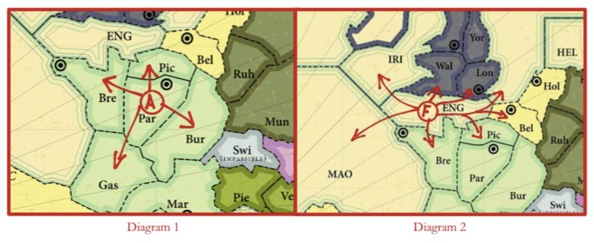

*Army movement example****:*** *An Army in Paris could move to Brest, Picardy, Burgundy, or Gascony. See Diagram 1.*

*-Fleet movement*

**A Fleet can be ordered to move to an adjacent water province or coastal province.**

Fleets can’t be ordered to move to an inland province. *Diagram 2 shows that a Fleet in the English Channel can move to the Irish Sea, Wales, London, Belgium, Picardy, Brest, the North Sea, or the Mid- Atlantic.*  
When a Fleet is in a coastal province, its warships are at any point along the coast of that province. A Fleet in a coastal province can be ordered to move to an adjacent coastal province only if it’s *adjacent along the coastline* (as if the Fleet was moving down the coast).

*For example, in Diagram 3 a Fleet in Rome can be ordered to move from Rome to Tuscany or to Naples (or to the Tyrrhenian Sea). But a Fleet in Rome can’t be ordered to move to Venice or Apulia because, although those provinces are adjacent along an inland boundary, they aren’t adjacent along the coastline.*

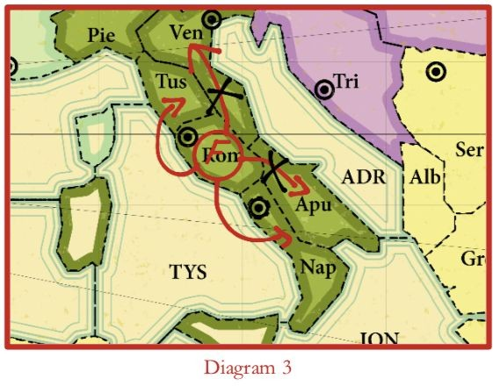

*-Restricted movement*

Any location on the game board that isn’t named can’t be occupied. Switzerland is impassable and can’t be occupied. With the exception of England, islands can’t be occupied.

*-Specific movement clarifications*

There are a few tricky areas on the map. How to move into and out of them is explained below:  
**Iran:** This is the only coastal province that has two separately *identified coasts.* A Fleet entering this province enters along one coast and can then move to a province adjacent to that coast only. The Fleet, nevertheless, is occupying the entire province. Such a Fleet should be placed on the coastline rather than completely inland.

If a Fleet is ordered to this province, the order must specify which coast, or the Fleet doesn’t move. *For example, a Fleet in the Caspian Sea can move to Iran’s North Coast. The order would be written “F Cas–Irn NC” or from the Persian Gulf to Iran’s South Coast “F Per–Irn SC.”*

**Kiel, Wolga, Nile:** Because of the waterways that run through these three provinces, they’re considered as having one coast. Fleets can enter them along one coast and be considered anywhere along the coastline. *For example, a Fleet could move from the Eastern Mediterranean to Egypt on one turn (“F Eme–Egy”) and then on a later turn move from Egypt to the Red Sea (or other adjacent provinces). Likewise, a Fleet could move from Holland to Hamburg on one turn and then move from Hamburg to Berlin on a later turn (through the Kiel Canal) without having to go around or go to Denmark.* Armies can also pass into and out of these provinces, freely bridging these waterways. This doesn’t mean that units can jump over these provinces. *The waterway from the Eastern Black Sea to the Caspian Sea takes two turns to pass because it goes through two provinces.*

**Sweden** and **Denmark:** An Army or Fleet can move from Sweden to Denmark (or vice versa) in one turn. A Fleet moving from Bornholm can’t move directly to the Skagerrak province (or vice versa), but must first move to Sweden or Denmark. The common border with Denmark doesn’t separate the coast of Sweden into two coastlines. Denmark doesn’t border on Berlin.

*-Standoffs*

The following common situations involve forces of equal strength trying to occupy the same province at the same time. These situations are called standoffs. These rules apply when one or more countries are involved.

**--Units of equal strength trying to occupy the same province cause all those units to remain in their original provinces.**

If two or more units are ordered to the same province, none of them can move. In Diagram 4, if the German Army in Berlin is ordered to Silesia and the Russian Army in Warsaw is ordered to Silesia, neither unit will move and Silesia will remain vacant.

**--A standoff doesn’t dislodge a unit already in the province where the standoff took place.** If two units (or forces of equal strength) attack the same province, thus standing each other off, a unit already in that province isn’t dislodged. So, in Diagram 4, if there had been a unit holding in Silesia, the results would be the same and the unit in Silesia would remain.

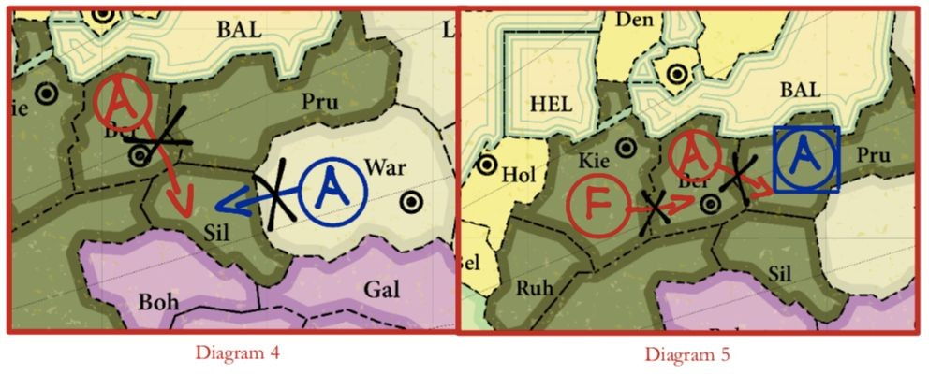

**--One unit not moving can stop a unit or series of units from moving.** If a unit is ordered to hold, or is prevented from moving, and other units are ordered into its province, those other units can’t move. (It’s like a traffic backup!). In Diagram 5, there is a Russian Army in Prussia. The Russian player told Germany that he would move out of Prussia (but he lied and ordered the Army to hold instead). The German player ordered his Army from Berlin to Prussia and his Fleet from Kiel to Berlin. The result is that nothing moves.

**--Units can’t trade places without the use of a convoy.** If two units are each ordered to the province that the other occupies, neither can move. For example, in Diagram 6, neither unit would move. (There is a way around this through the use of convoys discussed later in this document)

**--Three or more units can rotate provinces during a turn provided none directly trade places.**

*For example, in Diagram 7 all orders would succeed as no one unit directly trades places with another.*

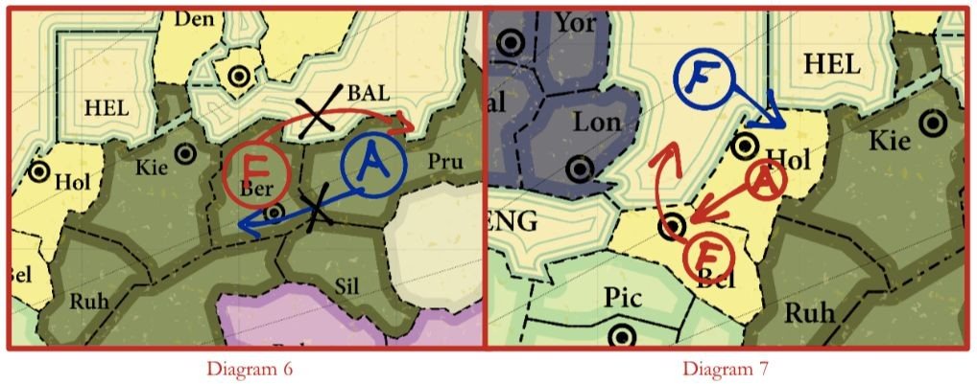

*-Support order  
This is the most critical and complex section of the rules.* The “support” and “cutting support” rules must be understood to be able to resolve most orders.

*Overview*

Since all units have equal strength, one unit can’t attack and advance against another without help. That “help” is called support. If an attack is successful, the attacking unit moves into the province to which it was ordered. If the unit that was attacked had no orders of its own to move elsewhere, it’s defeated and dislodged from the province. The dislodged unit must retreat or be disbanded.

An Army or Fleet can provide support to another Army or Fleet. Support can be offensive (supporting an attacking move order) or defensive (supporting a hold, support, or convoy order). By supporting each other, attacking or defending units gain increased strength. For example, a unit holding with two supports has the strength of three: itself plus two supporters. Support can be provided to a fellow unit or to another player’s unit. *Support can be given without consent and can’t be refused!* This can cause unexpected situations making it more interesting.

A unit moves with its own strength combined with all its valid supports. It can complete its move unless it’s opposed by a unit that is supported equally or better.

*Writing a support order*

1. Write down your unit type (A or F)
2. Write down the province where your unit is located
3. Write an “S” (for Support)
4. Write the type, current location and destination of the unit receiving support (if the supported unit is moving

*Example: “A Par S A Bor-Bri”**orders an Army in Paris to support an Army in Bordeaux moving into Brittany.*

*-How to support*

A unit gives up its chance to move on a turn to support another unit’s order. The province that a unit is providing support to must be one that the supporting unit could have legally moved to during that turn*. Thus, an Army in Brittany can’t support a Fleet in the English Channel because an Army can’t move into a water province. Likewise, a Fleet in Rome can’t support a unit’s move to Venice because, although adjacent by land, the Fleet can’t move to Venice from Rome.*

*-Supporting a unit*

**--A unit not ordered to move can be supported by a support order that only mentions its province**. A unit that is ordered to hold, convoy, support, or not ordered at all can receive support in holding its position. *For example, if the order is written “F Swe S F Bal,” then the Fleet in Sweden will support the Fleet in the Baltic Sea as long as the Fleet in the Baltic is holding, convoying, or supporting. If the Fleet in the Baltic attempts to move, then the support from Denmark is invalid.*

**--A unit ordered to move can only be supported by a support order that matches the move the unit is trying to make.** *For example, an Army in Silesia is ordered to support an Army in Czechia in its move to Krakow (A Sil S A Cze–Kra). However, the Army in Czechia is ordered to move to Saxony instead (A Cze–Sax). The support order fails because the move it’s supporting isn’t the move that was ordered. This support order doesn’t become a support order to hold.*

*-Simple support*

*In Diagram 8, the French Army in Gascony supports the Army in Marseilles to Burgundy. The German Army in Burgundy will be dislodged. In Diagram 9, the German Army in Silesia is supported by the Fleet in the Baltic in pushing the Russian Army out of Prussia. Note that the German Army and Fleet are both adjacent to the target province (Prussia) but not to each other.* A unit doesn’t have to be adjacent to the unit it’s supporting. However, it must be next to the province into which it’s giving support and must be able to legally move there itself.

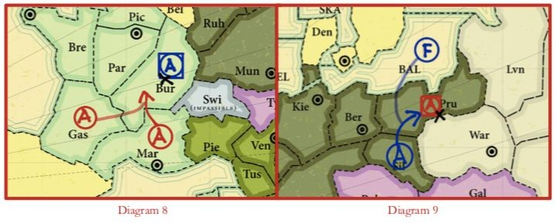

*-Support in standoffs*

Diagrams 10 and 11 show two common standoff situations. In both cases, a strength of 2 meets a strength of 2 and all units stand in place. In Diagram 10, if there had been a Fleet in the Tyrrhenian, it wouldn’t be dislodged by the standoff. (A standoff doesn’t dislodge a unit already in the province where the standoff took place.)

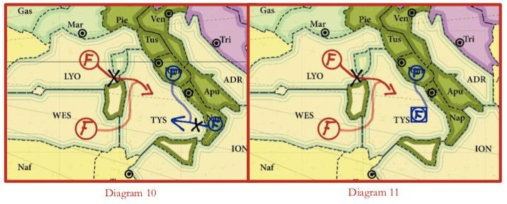

*-Dislodgement in standoffs*

**--A dislodged unit can still cause a standoff in a province different from the one that dislodged it.** When two or more equally supported units are ordered to the same province, neither can move—even if one of them is dislodged from a province *other than the one that is the target of the standoff during the same turn.*

*In Diagram 12, the Austrian attack from Bohemia successfully dislodges the Germany Army in Munich. However, that Army in Munich still causes a standoff with the Russian Army trying to enter Silesia.*

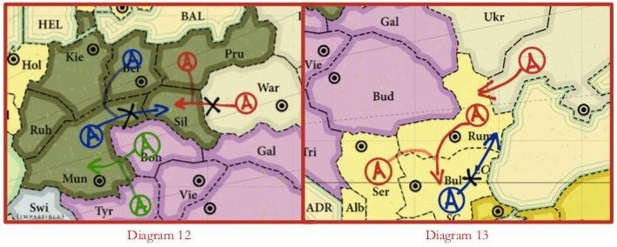

**--A dislodged unit, even with support, has no effect on the province that dislodged it.** If two units are ordered to the same province and one of them is dislodged by a unit coming from that province, the other attacking unit can move. This situation doesn’t result in a standoff since the dislodged unit has no effect on the province that dislodged it.

*In Diagram 13, the Russian Army in Rumania dislodges the Turkish Army in Bulgaria. That Turkish Army and the Russian Army in Sevastopol are both ordered to Rumania, which would normally cause a standoff. However, because Rumania dislodged the Army in Bulgaria, it has no effect on Rumania at all. This allows the Sevastopol Army to enter Rumania. The Army in Bulgaria must retreat.*

*In Diagram 14, even though the Turkish unit has support, it fails to prevent the unsupported Russian move into Rumania because a unit coming from Rumania dislodged the Turkish unit.  
In the previous two examples, if Russia hadn’t ordered “A Sev–Rum,” Rumania would have been vacant, but not as the result of a standoff (there was no standoff).*

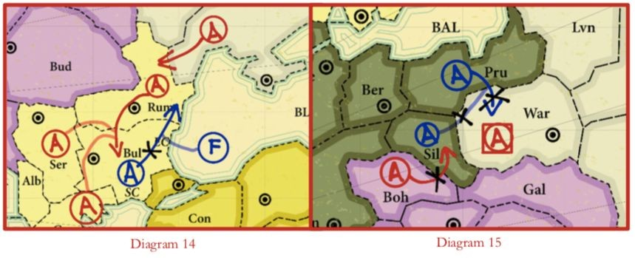

*-Cutting support*

Support can be cut. This will cause the support order to fail, and support won’t be given.

**Note:** In this rulebook, examples of support orders that failed are underlined to show that the support was cut, not to show that the supported unit’s order failed.

**--Support is cut if the unit giving support is attacked from any province except the one where support is being given.** The support cut whether this attack on the supporting unit succeeds or not. *In Diagram 15, the support from the Army in Silesia is cut by an attack from Bohemia.* It is enough to attack the Army giving support to cut that support so dislodging the supporting unit to cut that support is unnecessary.

**--Support is cut if the unit giving support is dislodged.** If a unit ordered to support another unit is dislodged by an attack from any province (including the province which it’s supporting) then the support is cut.

In *Diagram 16, the German support isn’t cut by the attack from Warsaw because that is the province into which support is being given. To cut support, the Army in Warsaw would have to dislodge the Army in Silesia, not merely attack it.*

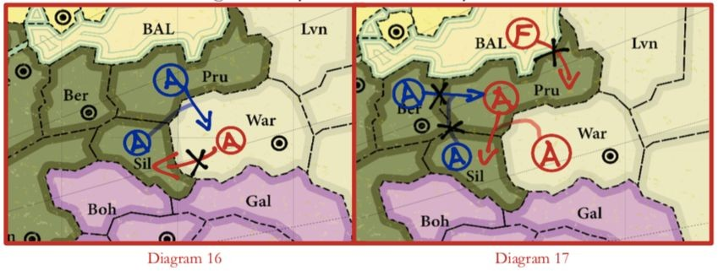

*In Diagram 17, the Russian Army coming from Prussia dislodges the German Army in Silesia. The support of the Silesian Army is thus cut and the German Army in Berlin stands off the Russian Fleet in the Baltic.*

**--A unit being dislodged by one province can still cut support in another province.** Just as a unit being dislodged by one province can still cause a standoff in another, a unit still manages to cut support even if it’s dislodged. Just make sure that the dislodgement isn’t coming from the province where the unit is giving support. **Note**: A dislodged unit, even with support, has no effect on the province that dislodged it.

**Note:** In complicated situations, it helps to first determine what support, if any, is cut. Once this is determined, it’s easier to resolve orders.

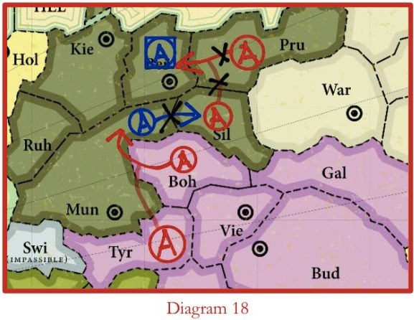

*In Diagram 18, even though the German Army in Munich is dislodged by a Russian attack, it’s still able to cut the support of the Russian Army in Silesia. This prevents the Russian Army in Prussia from entering Berlin.*

*-Convoy order  
Convoying an army across one water province*A Fleet in a water province (not a coastal province) can convoy an Army from any coastal province adjacent to that water province to any other coastal province adjacent to that water province. To do this, the Army must be ordered to move to the intended province and the Fleet must be ordered to convoy it.

**Note:** A Fleet can’t convoy a Fleet.

*Writing convoy orders*

Just as “S” indicates support, the letter “C” is used to indicate convoy. Following is an example of a convoy order: A Bri-Lon; F Eng C A Bri-Lon

A Fleet can’t convoy more than one Army during the same turn. The order to the Fleet must contain both the location and the destination of the Army being convoyed. Just as with support orders, the convoy order must match the move order given by the Army being convoyed.

**Note:** Fleets in any *coastal* province (including Constantinople, Denmark, and Kiel) can’t convoy.

In Diagram 20, the Fleet in the North Sea convoys the Army in London to Norway.

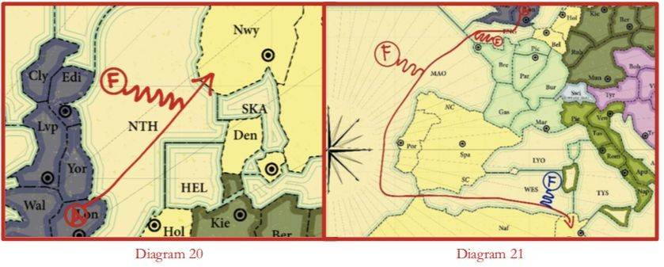

*“Support” can’t be convoyed*

Only Armies can be convoyed. “Support” can’t be transported from one Army via a convoy to another unit. For example, the underlined orders shown are illegal and clearly fail; England: A Pic-Bri; A Lon S A Pic-Bri; F Eng C A Lon S A Pic-Bri France: F Bri-Holds

*Convoying an Army across several water provinces*

If Fleets occupy adjacent water provinces, an Army can be convoyed through all these water provinces on one turn, landing in a coastal province adjacent to the final Fleet in the chain. *In Diagram 21, the English Army from London goes to Tunis on a single move with help from the French player.*

*Disrupting a convoy*

**--Dislodgement of a Fleet in a convoy causes the convoy to fail.** If a Fleet ordered to convoy is dislodged during the turn, the Army to be convoyed remains in its original province. An attack on a convoying Fleet, which doesn’t dislodge it, doesn’t affect the convoy.

**--A convoy that causes the convoyed Army to standoff at its destination results in that army remaining in its original province.** If a convoyed Army arrives at its destination province and is unable to stay there because of a standoff with another unit(s), then that convoyed Army must remain in its original coastal province. (It could still be forced out of its original province by a successful attack there.) An Army can be supported into its destination province to help avoid a standoff.

*In Diagram 21, the Fleet in the Tyrrhenian is dislodged, so the French Army doesn’t move from Spain to Naples.*

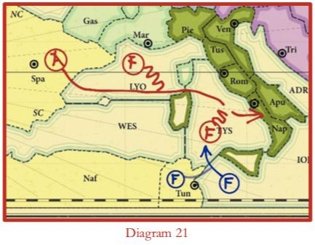

The Order resolving phase:

After all the orders have been revealed and read, the chairs must resolve all the conflicts. Resolution will result in successful moves, failed moves, standoffs, retreats, and disbandments. The units on the game board are moved and removed as described in the next two phases.

The Retreat and disbanding phase:

After all the orders have been revealed and read, the moves made, and the conflicts resolved, any dislodged (defeated) units make their retreat. These retreats are written down (just like orders) and revealed immediately. No diplomacy or discussion takes place prior to writing retreat orders—all countries are on their own. A dislodged unit must retreat to an adjacent province that it could ordinarily move to if unopposed by other units. Sometimes a retreat is made deeper into enemy territory.

A unit can’t retreat to:

* A province that is occupied;
* The province from which the attacker came; or
* A province that was left vacant by a standoff during the same turn

If there is no available province to retreat to, the dislodged unit is immediately disbanded and removed from the game board.

*-Writing retreats*

If two or more units must retreat, the retreat locations are immediately (and without discussion) written down by the players concerned. The written retreats are then simultaneously revealed. Retreats can’t be convoyed or supported. Each player should write the location of the dislodged unit and the location to which it’s retreating.

*-Disbandment*

If two or more units are ordered to retreat to the same province, they all must be disbanded. If a player fails to order a retreat when necessary, the unit is disbanded. A unit can voluntarily disband instead of retreating.

The Gaining and losing units phase:

*-Controlling supply centres*

After each Fall turn, players check to see how many supply centres they control. A country controls a supply centre when one of its units occupies that supply centre province after a Fall turn has been played and completed. Once a country gains control of a supply centre, it can leave the centre vacant and keep control of it, if that centre isn’t occupied by another country at the close of a Fall turn. A unit that moves into a supply centre during a Spring turn and moves out of it during the Fall of the same year doesn’t affect the ownership of the supply centre. In short, a country retains control of a supply centre if, at the end of each Fall turn (including retreats), the supply centre is either vacant or is occupied by one of its own units.

*-Adjusting number of units*

After each Fall turn (including retreats, if any), players adjust their units to match the number of supply centres they control. This may result in some units being disbanded (if the player has lost supply centres that year) or in some units being built (if the player has gained supply centres that year). As with retreats, gaining and losing units (adjustments) are written and revealed simultaneously without discussion or diplomacy of any kind.

*-Disbanding*

If a country has fewer supply centres than units, it must disband the excess number of units and may choose which to disband.

*-Building*

If a country has more supply centres than units, it can place new units in each unoccupied supply centre of its home country that it still controls. It can’t build units in supply centres outside its home country.

***Example:*** *The French player can build units only in Paris, Brittany, Lyon, Syria and French North Africa throughout the course of the game. However, if Lyon was under Italy’s control and the French player had a unit in Brittany, he or she would only be allowed to build in Paris, Syria and North Africa no matter how many builds France was entitled to on that turn. If the French player vacated Brittany and regained control of Lyon, he or she would be allowed to build there after another Fall turn (provided he or she was still entitled to build on that turn).*

*-Additional building rules*

Only an Army unit can be built on an inland province supply centre.

* When building a unit on a coastal province supply centre, a Fleet or Army must be specified in the written build order. *If a Great Power builds a Fleet in Iran, the player must also specify “North Coast” or “South Coast.”*
* If your country’s home supply centres are all occupied by units, then you can’t build during the current Fall turn. Remember to leave some home supply centres open if you intend to build new units in the Fall.
* If your country has lost all its home supply centres, you can still fight with the units (supplied by other centres) remaining under your control. In this case, you can’t build new units until you recapture a home supply centre and control it at the close of a Fall turn.
* A country can decline to build a unit it is entitled to. (diplomatic reasons)

*-Writing builds and disbandments*

Delegations write down which units they will disband (if any) and what type of unit will be built in a home supply centre (if any). These orders are written without diplomacy/discussion and revealed simultaneously; vague/invalid orders are ignored.

**Losing and regaining your country**

It is possible to lose your last supply centre and thus your last army or fleet. When that happens, you lose all your territory, your military presence and your country. You will be considered a province of the Great Power that took your last supply centre. A diplomats you can strive to regain your country. You retain any non-territorial victory points that are still applicable, and you may therefore even win the game without having any land, though rare.

The trick is to cause insurrections in the renegade province that once was your country. To succeed you will require aid from other Great Powers which each have the option of giving their armies or fleets an Insurrection order. This means the unit is disbanded and its weapons plus a few able men transported to the site of the insurrection and requires one season to succeed. *England: F I Lon-Russia; England disbands its fleet in London to support a Russian Insurrection.*

Any unit can support an insurrection anywhere. This surreptitious support is not subjected to the rules for movement of troops. If a Great Power that has lost its country manages to get the support of three units (from one, two or three Great Powers), it may at the end of the season of the insurrection reclaim three of the supply centres of its home country and build a unit there. If one gets the support of four units for an insurrection, then one regains all five supply centres. Any supply centre that is taken back must be unoccupied. For any occupied supply centre, an additional unit must join the insurrection.

A country to be revived must file orders to revive its country, explicitly stating which supply centres are to be regained, including order of preference in case less support is given than was expected. An order given without order of preference is considered invalid. It might happen that the supported country does not file (valid) orders to revive its country, or one of the promised units fails to turn up, the insurrection ends unsuccessfully.

Helping an insurrection costs a delegation a unit for one season, but that may well be a small price to pay for dealing a blow to an enemy that will suddenly see a Great Power revived behind its front lines, or for an enemy to suddenly have to fight a war on two fronts. Also, any Great Power investing at least two units in an insurrection gains a non-territorial Victory Point.

**Political Victory points**

A country can also gain political victory points. These points are rewarded for completing political goals. At the start of the conference, each Great Power will be provided with 3 political goals for their country alone. Each country may also propose two other achievement that will gain them victory points. This way, proper research into your country is directly rewarded in game terms. Any political goal proposed must be reasonably historically accurate for your country.

**Your personal political goals must be handed at least two days before MUNA. Your proposal will be evaluated by the chairs. They may allow or deny your goal and can award up to 3 victory points for the political goal.**

Here are some examples based on World War II events:

United Kingdom:

* Achieve ‘Peace for our time’ - Make sure the British Expeditionary Force escapes Germany’s troops in 1940 by evacuating them from Dunkirk
* Participate in the Yalta conference and make sure that Germany will be divided in a North German state, a South German state and a West German state after its surrender.

Union of Soviet Socialist Republics:

* Divide Poland between Germany and yourself
* Participate in the Yalta conference and ensure that Eastern Europe will be within the Soviet sphere of influence.

German Empire:

* Promise Russia a part of Poland in exchange for peace, but attack them afterwards anyway

**Organizing a conference**

A country can organize and / or participate in a congress, conference or convention. During this conference the invited countries can discuss an issue in private. If you want to organize such a conference, follow the steps and rules written below.

1. Determine the preliminary goal of the conference
2. Find other delegations that support you and determine the definite goal of the conference.
3. Determine the location and name of the conference.
4. Make sure that the area of the conference does not contain any army or fleet that is hostile to the conference.
5. Determine the participating delegations. No conference can be held with less than three delegations.
6. Fill in the ‘Conference Organizing Form’ which will be provided to you at the conference.
7. Go to the presidency to ask for a conference room.
8. The conference will commence: one or two of the chairs will preside over the conference.
9. The conference will last no longer than one year.
10. During the conference, the participating countries will have to send of their delegates to the conference room. The other will continue in the Situation Room.
11. During the conference, the game will continue, and the delegates present in the Situation Room will keep playing.
12. If the area where the conference is held is conquered, the conference will be cut short immediately. If delegations want to continue the conference, the entire procedure must be followed again.
13. Only one conference can take place at the same time.

