**Research Report**

**General Assembly 4**

***The question of the political status and future governance of Western Sahara***

*Student Officers:*

*Sidney Kouwenhoven and Iris Spruit*

**Introduction**

For many years, the political status and governance of Western Sahara have been a cause for conflict. Morocco asserts its sovereignty over the territory, while the indigenous Sahrawi Republic advocates for independence. To date, no peace treaty has been concluded to resolve the dispute.

Western Sahara was a Spanish colony from 1884 until Morocco’s independence in 1956, at which point Morocco reaffirmed its historical claim to the region. The United Nations supported efforts toward the decolonization of the Western Sahara, as it remained under Spanish control. However, the Polisario Front, an indigenous Sahrawi independence movement, rejected the notion of external governance over their territory. Their pursuit of independence led to a sixteen-year guerrilla war against Moroccan forces, ultimately ending in a UN-brokered ceasefire. The UN-brokered ceasefire put an end to the hostilities, but Morocco has yet to conduct a promised referendum on independence.

The key actors involved in this conflict supporting Morocco are the United States of America and France. The Democratic People's Republic of Korea (DPRK) and Mexico, on the other hand, have formally acknowledged the claims of the indigenous population of Western Sahara.

**The Committee**

General Assembly 4 is a fairly ordinary committee, meaning there are no special Rules of Procedure specific to this committee. In MUNA, General Assembly 4 deals with matters of special politics and decolonisation, which can include an immense number of topics. In this General Assembly, nations come together to discuss important global issues and collaborate to find solutions in a peaceful and respectful manner. When debating an issue during MUNA, one should be aware of the fact that money is never an issue. Therefore, a delegate should never vote or speak against resolutions because of financial reasons.

**Keywords**

Decolonisation: the process by which colonies become independent of the colonising country.

Guerrilla war: a form of irregular combat in which small army groups use ambushes, sabotage, and hit-and-run tactics against larger forces. It often occurs in remote or rugged environments, such as forests or mountains, where fighters utilize natural cover to evade detection and strike strategically.

Indigenous population: distinct social and cultural groups that share collective ancestral ties to the lands and natural resources where they live.

Sovereignty: supreme power over a region, free from external control.

**Overview**

About the Western Sahara

Western Sahara, located in North Africa, spans about 266,000 square kilometres. It is bordered by Morocco, Algeria, Mauritania, and the Atlantic Ocean. The region's climate is arid, dominated by desert conditions. Its population is estimated at 600,000, with Laayoune (El Aaiún) as the largest city. Economically, Western Sahara relies on its rich phosphate reserves, abundant fisheries, and potential offshore oil and gas deposits. The territory's natural landscape and sparse vegetation shape its primarily subsistence-based agriculture and mining industries.

Countries and their stance on the issue

|  |
| --- |
| **Countries recognising Morocco’s claim to sovereignty in the Western sahara** |
| United States of America (recognised in 2020) |
| Central African Republic (recognised in 2022) |
| The Netherlands (recognised in 2022) |
| Spain (recognised in 2022) |
| Ukraine (recognised in 2023) |
| Israel (recognised in 2023) |
| France (recognised in 2024) |
| Brazil (recognised in 2024) |

|  |
| --- |
| **Countries remaining neutral / supporting the UN-led process** |
| Germany (supports Morocco’s autonomy plan but stops at full recognition) |
| Russia (no outright support towards a specific group) |
| China (no outright support towards a specific group) |
| India (Promote a UN solution that respects the Sahrawi people's right to self-determination) |

|  |
| --- |
| **Countries supporting Sahrawi Republic, the native inhabitants** |
| Mexico |
| DPRK |
| South Africa |
| Vietnam |
| Syria |

*Significant Historical Events*

The Green March (November 6, 1975)

The Green March was a mass demonstration in November 1975. It was controlled by the Moroccan government under the reign of King Hassan II and its army to force Spain to hand over the colonised Spanish Sahara. Spain was already preparing to abandon the territory, as it was a part of the Decolonisation of Africa (a series of political developments in Africa during the Cold War). The Green March is a significant milestone in the history of Western Sahara, signalling the start of the long-standing territorial dispute involving Morocco, Mauritania, and the Polisario Front, which supports Sahrawi independence. The march also strengthened King Hassan II’s domestic support by uniting Moroccans around a nationalistic cause.

The Madrid Accords (November 14, 1975)

The Madrid Accords, formally the *Declaration of Principles on Western Sahara*, is a treaty between Spain, Morocco, and Mauritania signed on the 14th of November 1975. The Western Sahara, at the time still under the control of Spanish authorities, was demanded by both Morocco and Mauritania. In the accord, Spain mainly agreed to decolonise the Territory of Western Sahara. Also, all parties agreed to respect the views of the native Saharan population. To understand more about the Madrid Accords of 1975 and its terms, look at the following sources:

*MOROCCO, MAURITANIA and SPAIN Declaration of Principles on Western Sahara. Done at Madrid on 14 November 1975*. 14 Nov. 1975. Retrieved from: https://treaties.un.org/doc/publication/unts/volume%20988/volume-988-i-14450-english.pdf

Wikipedia. “Madrid Accords.” *Wikipedia*, 22 Mar. 2020, en.wikipedia.org/wiki/Madrid_Accords. Accessed 2 Dec. 2024.

Map of the Conflict

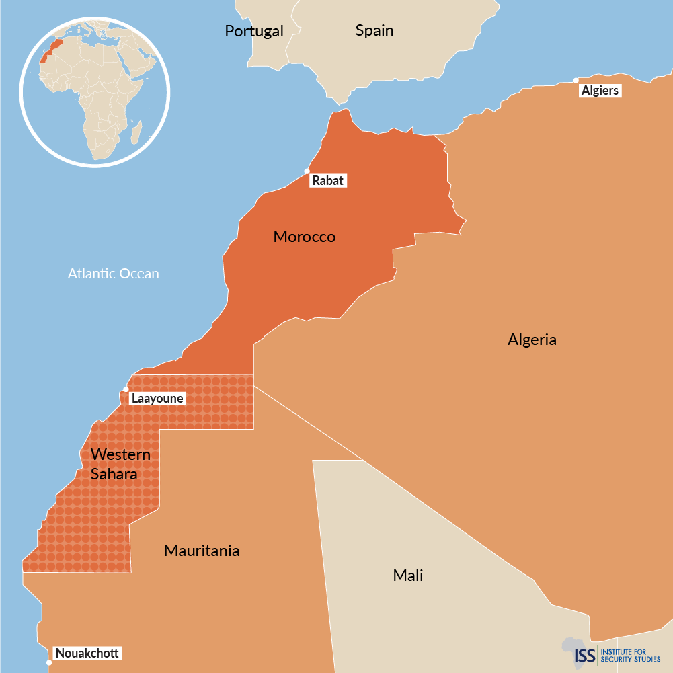

**Arguments**

Potential arguments in favour of Morocco’s sovereignty over the Western Sahara

**Proposed Autonomy Plan**: In 2007, Morocco suggested giving Western Sahara limited self-rule under Moroccan sovereignty. This plan includes local control over governance, courts, and cultural preservation. Supporters believe this compromise promotes stability and development.

**Investment in the Region**: Morocco has made significant investments in Western Sahara, building infrastructure, improving healthcare, and enhancing education through its "New Development Model for the Southern Provinces." These efforts demonstrate Morocco's commitment to improving the lives of the region’s population.

**Geopolitical Stability**: Proponents argue that Moroccan control supports regional stability and reduces risks like terrorism and illegal migration. Morocco is considered a dependable ally by countries such as the U.S. and members of the European Union in managing North African security challenges.

**Growing Diplomatic Support**: Several countries, including the U.S. and Israel, have recently recognised Morocco’s sovereignty or opened consulates in the region. This trend reflects an increasing global acknowledgement of Morocco’s position.

Potential arguments against Morocco’s sovereignty over the Western Sahara

**Right to Self-Determination**: Critics argue that the Sahrawi people, represented by the Polisario Front, deserve the right to decide their future through a UN-led referendum. They see Moroccan control as disregarding international law and human rights.

**UN Agreements**: The United Nations classifies Western Sahara as a "non-self-governing territory" and has called for an independence referendum. Opponents accuse Morocco of delaying this process and undermining agreements established by the UN.

**Resource Exploitation**: Opponents claim Morocco benefits unfairly from Western Sahara’s natural resources, such as phosphates and fisheries, without proper consent or equitable benefits for the Sahrawi population.

**Regional Tensions**: Algeria, which supports the Polisario Front, argues that Moroccan sovereignty increases conflict in North Africa. This rivalry affects regional trade and diplomatic relations.

*!!! Please note that these points are intended as a general framework to guide your preparation for the debate on Western Sahara. Delegates are encouraged to tailor their arguments to align with their assigned country’s policies and unique context. Replicating these points directly is discouraged to ensure a constructive and engaging discussion.*

**Timeline of events**

**1884,** Spain colonised the Western Sahara.

**1934** Western Sahara is designated a Spanish province, known as the Spanish Sahara.

**1956** Morocco achieves independence.

**1957** Morocco reinforces its long-standing claim to Western Sahara.

**1963** The UN lists Western Sahara as a non-self-governing territory, recognizing the Sahrawis' right to self-determination.

**1965** The UN encourages the decolonization of Western Sahara.

**1973** The Polisario Front, an indigenous Sahrawi independence movement, is established with assistance from Libya and Algeria due to their historical connections with the indigenous people of Western Sahara.

**1975** The International Court of Justice (ICJ) issues an advisory opinion, recognising the Sahrawi people's right to self-determination but acknowledging historical ties between Morocco, Mauritania, and Western Sahara. Morocco annexed Western Sahara against the advice given by the ICJ during the ‘Green March’ as Spain withdrew. The Madrid Accords were signed (a treaty between Spain, Morocco and Mauritania). Under the agreement, the territory would be divided between Morocco and Mauritania.

**1975-1991** The Polisario Front engages in a sixteen-year guerilla war against Moroccan forces, which concludes with a UN-brokered ceasefire.

**1976** On February 27, 1976, just before Spain officially left the province, the Polisario Front declared the Sahrawi Arab Democratic Republic (SADR) in Western Sahara.

**1979** Mauritania signed a peace treaty with the Polisario Front and subsequently withdrew from the area.

**1991-2000s** The UN-brokered ceasefire puts an end to hostilities, but Morocco has yet to conduct a promised referendum on independence.

**2020** The US, under President Trump, announces its recognition of Morocco's full sovereignty over Western Sahara in return for Morocco establishing relations with Israel.

**2021** Morocco puts forward a proposal for autonomy in Western Sahara under the sovereignty of the King of Morocco.

**2022** Spain acknowledges Morocco's proposal as "the most serious, realistic, and credible basis" for resolving the dispute over Western Sahara, though Sahrawi political parties reject it.

**2023** Israel recognizes Morocco's claims over Western Sahara.

**Resolution**

A delegate should carefully consider their country's perspective and opinion on the matter when writing a resolution. This research report is a good starting point for your investigation. Consider ways to debate on the independence of the non-self-governing territories that benefit the most countries involved. Remember to pay attention not only to the less-developed countries involved in the issue, but also to the developed countries. Goals should be realistic and attainable. Furthermore, keep in mind that different countries have different policies, as well as global differences. These differences may be economic, but they are also primarily cultural. Make sure to thoroughly research your country and remember that you are speaking as if you are representing that country. Therefore, before attending the conference, do some research on your country’s policies.

For more information on resolution writing, please refer to the MUNA booklet on our MUNA site: <https://munalfrink.nl/>.

**Links and sources**

<https://www.youtube.com/watch?v=m6sruNoegEE>

<https://en.wikipedia.org/wiki/Madrid_Accords>

<https://www.usip.org/publications/2024/08/western-saharas-conflict-over-negotiating-terms-comes-next>

<https://en.wikipedia.org/wiki/Western_Sahara_conflict>

<https://unacademy.com/content/daily-news-analysis/the-western-sahara-dispute/>

<https://www.bbc.com/news/world-africa-14115273>

<https://issafrica.org/iss-today/western-sahara-s-quest-for-independence-seems-to-be-flagging>

<https://geographical.co.uk/news/geopolitics-france-ignores-un-and-eu-in-supporting-moroccos-claim-to-western-sahara>

<https://treaties.un.org/doc/publication/unts/volume%20988/volume-988-i-14450-english.pdf>