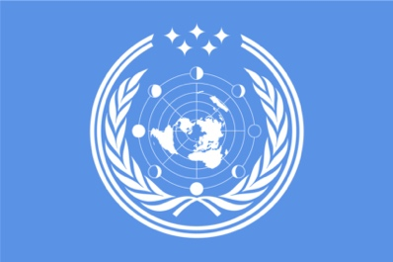
Research Report

Future council

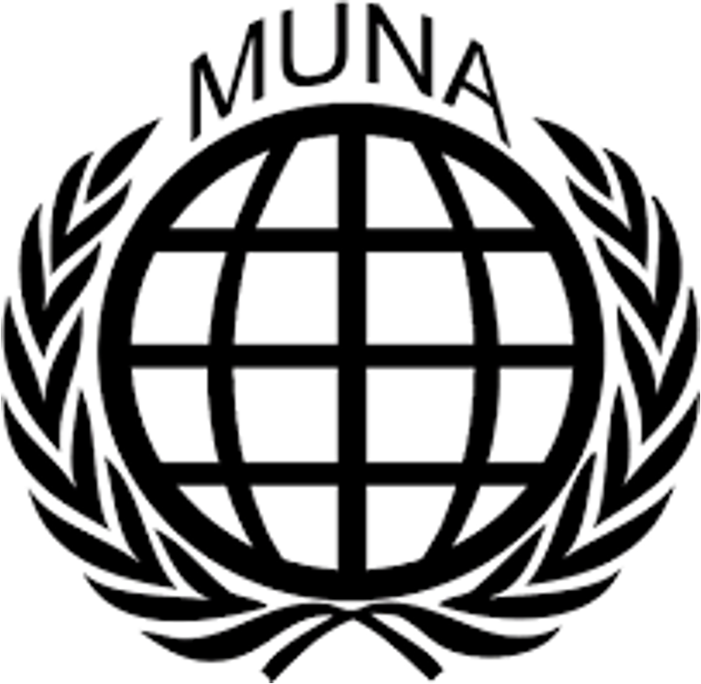

2100: Lunar and outer space rights

Student Officers:
Justin van Rhoon & Igor de Groot

Introduction
Establishing treaties and international laws concerning the permanent settlements on the surface of the moon is a complex and multifaceted issue. One key concern is the rights of nations, 'colonies', and individuals in regard to the resources and equipment on the moon. The current moon treaty, which was signed in 1979 and entered into force in 1984, outlines the principles governing the exploration and use of outer space and celestial bodies. According to the treaty, the moon and other celestial bodies should be used for peaceful purposes only and are the common heritage of mankind. However, the treaty does not address the issue of ownership and sovereignty of the moon and its resources in detail. This has led to debates about who has the right to claim ownership of the moon and how this would be governed. Another issue to consider is the possibility of a self-sufficient lunar colony and the possibility of a sovereign moon-state. Developing a self-sufficient lunar colony would involve creating a sustainable ecosystem that can support human life without the need for constant resupply from Earth. The possibility of a sovereign moon-state, on the other hand, would involve the creation of a separate government with its own laws and regulations. Finally, there are also questions about the rights and obligations of space agencies, states, and private corporations in terms of operating, maintaining, and using the space elevator or skyhook. This futuristic technology has the potential to revolutionize space travel by providing a less energy-intensive method for getting spacecraft out into orbit. However, it is not yet clear who will have the rights to build and operate the skyhook, and what obligations they will have to other nations and space agencies. These are the main issues that will need to be addressed in any treaty concerning the permanent settlements on the surface of the moon.

The Committee

The future council is a committee within the MUNA organization that is dedicated to addressing and discussing issues that will occur in the future. Each nation is represented by two delegates. The council is set to address three specific issues that will take place at three different points in time: 25 years from now (2050), 50 years from now (2075), and 75 years from now (2100). To assist in your discussions, the council has been provided with three research reports containing comprehensive informational materials and detailed information about technological advancements and other relevant aspects of the future. There are currently 17 recognized nations, federations, or unions that are affiliated with the council. The boundaries of these countries can be viewed on the "New World Order Map". It is essential to keep in mind that this information may change or be modified as the council moves through various time periods in the future.

Keywords

Lunar rights refer to the rights of nations, colonies, and individuals in regard to the resources and equipment on the surface of the moon. These rights may include the right to explore and use the moon and its resources for peaceful purposes, the right to access and use equipment and facilities on the moon, and the right to participate in scientific research on the moon. The specific rights and obligations associated with lunar rights are often outlined in international agreements and treaties.
Outer space rights refer to the rights of nations, space agencies, states, and private corporations in regard to operating, maintaining, and using space-based infrastructure, such as satellites, space stations, and other spacecraft. The specific rights and obligations associated with outer space rights are often outlined in international agreements and treaties.

Permanent settlements refer to permanent bases or colonies that are established on the surface of the moon or other celestial bodies. These settlements may be used for a variety of purposes, including scientific research, resource extraction, and space tourism.

Sovereignty is the authority of a state or government to govern itself independently. It refers to the right of a state to make and enforce its own laws, regulate its own affairs, and control its own territory without interference from other states or external bodies.

A skyhook is a hypothetical space elevator that is anchored to a celestial body, such as a planet or moon. The skyhook is a concept in space travel that has been proposed as a way to lift spacecraft from the surface of a celestial body into orbit using less energy than traditional rocket propulsion.

Self-sufficiency refers to the ability to provide for all of one's own needs without external assistance. This may refer to the ability of a lunar colony or settlement to produce or obtain all of the resources it needs to sustain itself, including food, water, oxygen, and other necessities.

A lunar colony is a settlement on the surface of the moon. It is a place where people can live, work, and perform a variety of activities, such as scientific research, resource extraction, and space tourism. It may be a permanent or temporary settlement, and may be self-sufficient or reliant on external resources.

Overview

The creation of permanent settlements on the surface of the moon involves a number of complex issues, including the rights and responsibilities of various parties in relation to the resources and equipment on the moon, the potential for a self-sufficient lunar colony, and the rights and obligations of different entities in relation to the use of space elevator technology. The moon treaty of 1979 establishes principles for the peaceful use of outer space, but does not address issues of ownership and sovereignty in detail. As such, there are ongoing debates about who has the right to claim ownership of the moon and how this would be governed. These issues must be addressed in any treaty relating to permanent settlements on the moon.

Technical advancements

Here are four technical inventions that are related to lunar and outer space rights:

- A system for tracking and regulating lunar mining operations is already in place, ensuring that mining activities are conducted in a sustainable and equitable manner. This system tracks the location and activities of mining operations, as well as any materials extracted from the moon. It also includes regulations and guidelines for responsible mining practices, such as limits on the amount of material that can be extracted and requirements for the restoration of mined areas.
- Reusable lunar landing and take-off systems are now available, minimizing the environmental impact of space travel. These systems, such as reusable rockets and electric propulsion systems, allow for the launch and landing of vehicles on the moon with minimal emissions.
- A network of lunar communication and navigation satellites is in orbit around the moon, enabling the coordination and facilitation of lunar exploration and exploitation efforts. These satellites transmit data and images back to Earth, as well as enabling communication between various lunar missions and assets.
- Advanced robotics technologies have been developed for use on the moon's surface, facilitating tasks such as scientific research, construction and maintenance of lunar habitats, and exploration of the moon's resources. These robots have specialized sensors and manipulators, and can be remotely controlled from Earth. They are able to operate effectively in the moon's harsh environment.
Resolution
A resolution is a formal proposal made to a United Nations (UN) council, committee, or commission. It is intended to represent the position of a majority of UN member states, rather than just one country. In order to write a resolution, you should follow these steps:

- Determine the background and context of the issue you want to address.
- Write the preambulatory clauses, which introduce the issue and provide context.
- Develop the operative clauses, which contain clear policy statements on what the UN should do or adopt in regard to the issue.
- Present the resolution formally, including a heading with the committee name, main sponsor and signatories, topic or issue, and any co-sponsors or co-submitters.
- Follow formatting guidelines, including underlining the opening verb of each clause, separating clauses with line spaces, numbering operative clauses, indicating sub-clauses with letters and sub-sub-clauses with numbers, and using appropriate punctuation.

It is important to note that, rather than just copying clauses from past resolutions or resolutions from previous conferences, it is best to write your own resolution from scratch in order to better defend and debate it during the conference.

You may find the following pages to contain useful country information that is relevant to your research. This information has been carefully compiled and may prove valuable as you conduct your research.

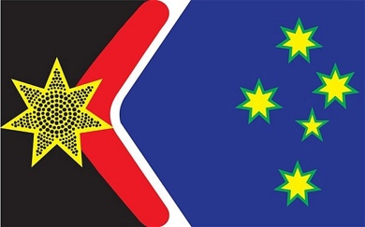
Origin Story
The African Union existed prior to the New World order. However just like the European Union the African Union was rather an alliance than an actual country. After the start of the New World Order several member states thought it would be wise if they too united themselves to protect themselves and further strengthen their bond. They are now widely seen as the diplomatic centre of the world where many alliances have been signed. The African Union is a relatively well-developed country, which thrives on establishing diplomatic relations.

Economic information
GDP: $1,61 trillion
Main income sources:
- Rubber production
- Solar Power
- Diplomatic centre
Currency: Owera
Gini coefficient: 0,394
Top trade relations:
- East-Latin Kingdom
- Saharan District
- Central Powers
Political information
Head of state: Premier Ashraf Bishara
Legislative power: Government
Political orientation: Left wing, socialist
Government seat: Abuja
Allies: Ottoman Empire, Saharan District
Enemies: Islamic State
General country information
Name: African Union
Capital: Lagos
Population: 368.621.978
Area: 4.894.614 km²
Official language(s): Swahili, English, French
Demonyms: Africans
HDI: 0,721

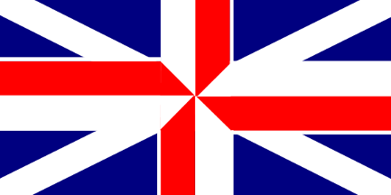
General country information
Name: British Empire
Capital: London
Population: 234.593.394
Area: 10.859.927 km²
Official language(s): English
Demonyms: Britons
HDI: 0,794

Origin Story
Obsessed with the former glory of the British Empire, King William decided that because the world was in chaos already it was the perfect time to attempt to restore such glory. The entire British fleet went along the old sailor route towards the east. On their way through they conquered the south of Africa however when they reached the Southern Islands they soon realised that conquering them simply was not worth the reward; so they took New Zealand and went back home. Australia was asked to join the Southern Islands however they soon realised that aid from the British Empire was of much greater value with the large communistic world powers above their head. They agreed to become a part of the British Empire with the right to some minor autonomous decisions. The British Empire is now a large monarchy, which thrives of the large money supplies going around the world. The British Empire and especially the British Isles are widely considered to be one of the largest service providers around the world, especially when it comes to the large sums of money that go around the globe.

Economic information
GDP: $5.89 trillion
Main income sources:
- Banking/ Finance
- Construction
- Healthcare
Currency: British Pound
Gini coefficient: 0,537
Top trade relations:
- North-American Union
- Central Powers
- Congo State
Political information
Head of state: King William VI (Windsor-Mountbatten)
Legislative power: King William VI (Windsor-Mountbatten)
Political orientation: Right wing, capitalist
Government seat: London
Allies: North-American Union, Central Powers, Congo State
Enemies: Southern Islands, Communist Republic, ISIS
Political information
Head of state: Premier Fleur Therrien
Legislative power: Government issued democracy
Political orientation: Centre-left, Capitalist
Government seat: Brussels
Allies: Scandinavian Democracy, North American Union, British Empire
Enemies: Islamic State, Korean Republic, Communist Republic
General country information
Name: Central Powers
Capital: Brussels
Population: 421.938.947
Area: 3.287.678 km²
Official language(s): French – German – Spanish – Italian
Demonyms: Europeans
HDI: 0,939

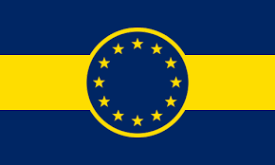
Economic information
GDP: $20.49 trillion
Main income sources:
- Service sector (tourism)
- Manufacturing industry
- Pharmaceuticals
Currency: Euro
Gini coefficient: 0,438
Top trade relations:
- North-American Union
- Chinese Empire
- African Union
Origin Story
As the other major world powers united and increased their strength, the European Union was losing its economic and political power. Therefore, the member states decided to unite and form one country, the Central Powers. This was mostly caused by the rapid expansion of the Communist Republic as the European Union was afraid of losing some or most of its countries. This country is comprised of the former countries in the European Union, excluding those who left and went on to form other countries and major powers. Today the central powers are a politically and economically strong country with a lot of allies and enemies. As the countries united they decided to hold onto the euro and keep their major trade relations and exports the same as before the new world order. The Central powers are the number one producer of pharmaceuticals this has lead to them having a very good HDI and giving them a major economic boost. As the water level has risen over time the Central Powers have decided to keep investing in their water management and have now become the best and sole supplier of dykes and other forms of water management.

Political information
Head of state: Emperor Chao IV
Political power: Government
Political orientation: Communist (socialist to certain extent), left wing
Government seat: Beijing
Allies: Communist Republic, Korean Republic, Ticoast Empire, Southern Islands
Enemies: North-American Union, Islamic State, Congo State
General country information
Name: Chinese Empire
Capital: Beijing
Population: 3.583.394.263
Area: 13.855.593 km²
Official language(s): Mandarin
Denonyms: Chinese
HDI: 0.564

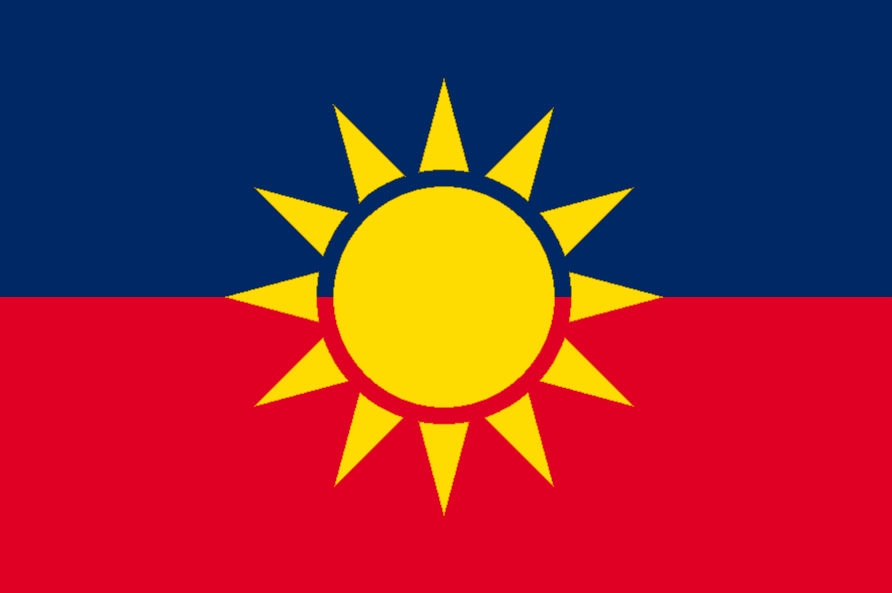
Origin Story
In the year 2037 China invaded several neighbouring countries, this because they believed that their way of thinking was the only right way of thinking and if people did not understand that they were inferior and therefore their lands belonged to China. The emperor renamed China into the Chinese Empire to show his status as the leader of one of the largest countries in the world. Nowadays China has the largest economy in the world sitting at over 30 trillion US$. They manufacture ~60% of everyday products and a large portion of the world is depended on them. The Chinese Empire is also one of the most controlled states where practically every citizen is watched closely on their behaviour, at the first sign of any trouble that person ‘disappears’. The Chinese Empire is slowly increasing its international position and has truly become one of the world’s most powerful countries in the world.

Economic information
GDP: $ 34.02 trillion
Main income sources:
- Manufacturing
- Agriculture
- Mining
Currency: Yuan
Gini coefficient: 0.235
Top trade relations:
- Communist Republic
- African Union
- Central Powers

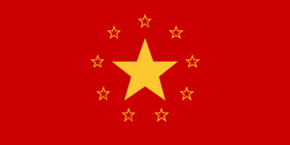
Political information
Head of state: Chairman Michael Yermakov
Political power: Chairman Michael Yermakov
Political orientation: Communist
Government seat: Moscow
Allies: Chinese Empire, Korean Republic, Ticoast Empire
Enemies: North-American Union, British Empire, Central Powers
General country information
Name: Communist Republic
Capital: Moscow
Population: 275.031.394
Area: 21.498.962 km²
Official language(s): Russian
Denonyms: Communists, Soviets
HDI: 0.732

Economic information
GDP: $ 18.49 trillion
Main income sources:
- Metals
- Uranium
- Wood export
Currency: Ruble
Gini coefficient: 0,185
Top trade relations:
- Chinese Empire
- Korean Republic
- Equatorian State
Origin Story
With the world looking in disbelief at the Chinese invasion Russia quickly reacted by invading their western neighbours, unable to react they were quickly crushed under the machine that was the Russian regime. Communism was reintroduced and within a year nearly everything was state owned. Right now, every citizen of the Communist Republic earns the same amount of money and their profession is chosen by the state via a nationwide test taken by inhabitants at the age of 18. The Communist Republic is one of the largest military powers and a public supporter of the Ticoast Empire. Striving for ultimate equality following the beliefs of Karl Marx the Communist Republic remains a key player for the Communist side of The New World Order.

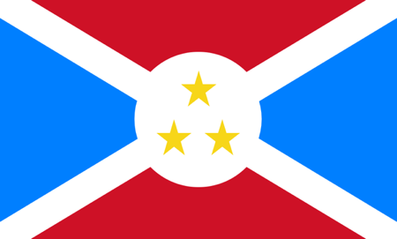
Political information
Head of state: President Bilal Jabir
Legislative power: Government
Political orientation: Left wing, capitalist
Government seat: Kinshasa
Allies: Central Powers, Chinese Empire, African Union
Enemies: Ticoast Empire, Communist Republic
General country information
Name: Congo State
Capital: Kinshasa
Population: 181.693.547
Area: 6.148.065 km²
Official language(s): Swahili, French, Lingala
Demonyms: Congolese
HDI: 0,415

Economic information
GDP: $5.37 trillion
Main income sources:
- Mining
- Foreign aid
- Wood export
Currency: Congolese Franc
Gini coefficient: 0,547
Top trade relations:
- North-American Union
- African Union
- Central Powers
Origin Story
As the countries surrounding the Congo State started forming alliances and joining forces the Congo State was forced into uniting, as this was the only way it would not be captured and be put under rule of another country. Ever since the war the Congo State has been looking for allies to help it grow economically and politically, the major investors and allies are the North-American Union, Central Powers and British Empire. Ever since the war the Congo State has been in conflict with the Ticoast Empire as they are supported by other major powers that are opposing the major world powers supporting the Congo State. Therefore, the Congo State and the Ticoast Empire have become the playground for today’s major world powers to show off their power. The Congo State and the Ticoast Empire are not on speaking terms. Today the Congo State’s priority is assorting their dominance over the Ticoast Empire and growing their economy. The major income sources are slowly deteriorating and it is therefore urgent that major economic strides will be made to increase the standard of living.

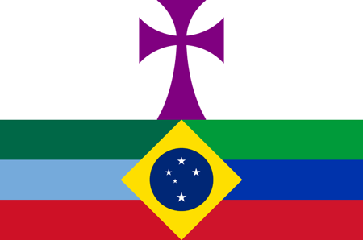
Political information
Head of state: Queen Emiliana Quintana
Legislative power: Queen Emiliana Quintana
Political orientation: Centre, capitalist
Government seat: Brasilia
Allies: West-Latin State, Equatorian State, Central Powers
Enemies: North-American Union, Islamic State, Chinese Empire
General country information
Name: East-Latin Kingdom
Capital: Brasília
Population: 271.493.021
Area: 11.576.085 km²
Official language(s): Portuguese – Dutch – French
Demonyms: Southerners
HDI: 0,721

Economic information
GDP: $3,55 trillion
Main income sources:
- Wood export
- Agriculture
- Mining
Currency: Real
Gini coefficient: 0,575
Top trade relations:
- Equatorian State
- West-Latin State
- Central Powers
Origin Story
Struck with fear after the world took such a crazy turn, Brazil started to gather strength from the neighbouring countries. These countries were glad to join the major power that was Brazil. Brazil gave the West-Latin State the opportunity to join their Kingdom; the West-Latin State declined this offer, as they did not want to be ruled by a monarch. Ever since the World War Brazil needed someone to lead them through the tough times the, this was when theQuintana family took charge of the country. The entire country supported them and they have lead the people of the East-Latin Kingdom through very hard times. All countries of South-America and Middle America are very friendly towards each other. A lot of trade still occurs between the countries in South- and Middle America and they are each other’s top trade relations. Today the East-Latin Kingdom is focussed on maintaining their relationship with the West-Latin State and the Equatorian State and on increasing their economic and political power.

Political information
Head of state: President Melinda Ojeda
Legislative power: President Melinda Ojeda
Political orientation: Right-wing, capitalist
Government seat: Mexico City
Allies: African Union, West-Latin State, East-Latin Kingdom
Enemies: Korean Republic, Islamic State
General country information
Name: Equatorian State
Capital: Mexico City
Population: 283.593.053
Area: 4.209.389 km²
Official language(s): Spanish
Demonyms: Equatorials
HDI: 0,739

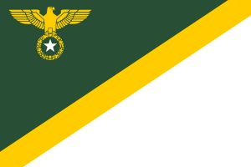
Economic information
GDP: $4,49 trillion
Main income sources:
- Textile
- Mining
- Service sector (including the Panama Canal)
Currency: Petals
Gini coefficient: 0,409
Top trade relations:
- East-Latin Kingdom
- West-Latin State
- Chinese Empire
Origin Story
Not being allowed to join the North-American Union due to their “unstable” government as the US called it. Mexico started looking towards the south for allies. Prompted by the ongoing wars in the east countries quickly joined in this initiative. Nowadays Equatorian State works close together with their southern neighbours. They are one of the major textile producers, which causes a healthy trade with the Chinese Empire who is in dire need of textile for their clothes.

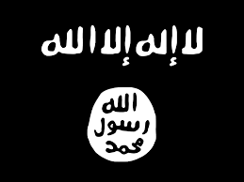
Political information
Head of state: Caliph Abdul-Nasir Sulayman Attia
Political power: Caliph Abdul-Nasir Sulayman Attia
Political orientation: Islamic Salafism, Salafi Jihadism, Islamic Fundamentalism, Wahhabism
Government seat: Baghdad
Allies: Saharan District
Enemies: North-American Union, Central Powers, Chinese Empire
General country information
Name: Islamic State
Capital: Baghdad
Population: 522.872.120
Area: 8.189.627 km²
Official language(s): Arabic
Demonyms: Islamic
HDI: 0,533

Economic information
GDP: $8,07 trillion
Main income sources:
- Oil
- Weapon export
- Production of cement
Currency: Dinar
Gini coefficient: 0,348
Top trade relations:
- Saharan District
- North-American Union
- Ottoman Empire
Origin Story
Near their defeat, the invasion of China was a golden opportunity for the caliphate Islamic State. While every country was fighting each other, or fighting for themselves they were given free reign, silently they overtook several countries and by the time the major world powers realized what was happening it was far too late, Islamic State had claimed land for themselves and there was very little that could be done without going into a full-blown war again which the already weakened countries could not risk. Right now, Islamic State is a strong power being the only country that still has oil. However, they also realize that the major world powers have recovered from their wounds and now eagerly look towards the oil supply of the still somewhat unstable Islamic State. This brings them in a double situation where they are the only ones with a certain resource but are bearably able to defend such resource.

Origin Story
As the start of the war was very close, no one paid attention to what the DPRK was doing. As the USA was busy joining forces with Canada and focused their attention on China and Russia they were too busy to help South Korea fend off the attacks of the DPRK. After the DPRK took control over South Korea; Japan was soon to follow. This took place over only three months and when the major powers realised it was far too late. Today the Korean Republic is allies with the Chines Empire and the Communist Republic and stands strong among the other countries surrounding it. The Korean Republic’s goal is to increase in overall power.

Economic information
GDP: $7,32 trillion
Main income sources:
- Defence equipment
- Electronics
- Primary form plastic
Currency: Won
Gini coefficient: 0,248
Top trade relations:
- Chinese Empire
- Communist Republic
- East-Latin Kingdom
Political information
Head of state: Supreme Leader Hyon Tae-Won
Political power: Government
Political orientation: Left wing, communist
Government seat: Pyongyang
Allies: Chinese Empire, Communist Republic, Ottoman Military
Enemies: North-American Union, Central Powers, Southern Islands
General country information
Name: Korean Republic
Capital: Pyongyang
Population: 221.820.434
Area: 623.356 km²
Official language(s): Korean
Denonyms: Koreans
HDI: 0,546

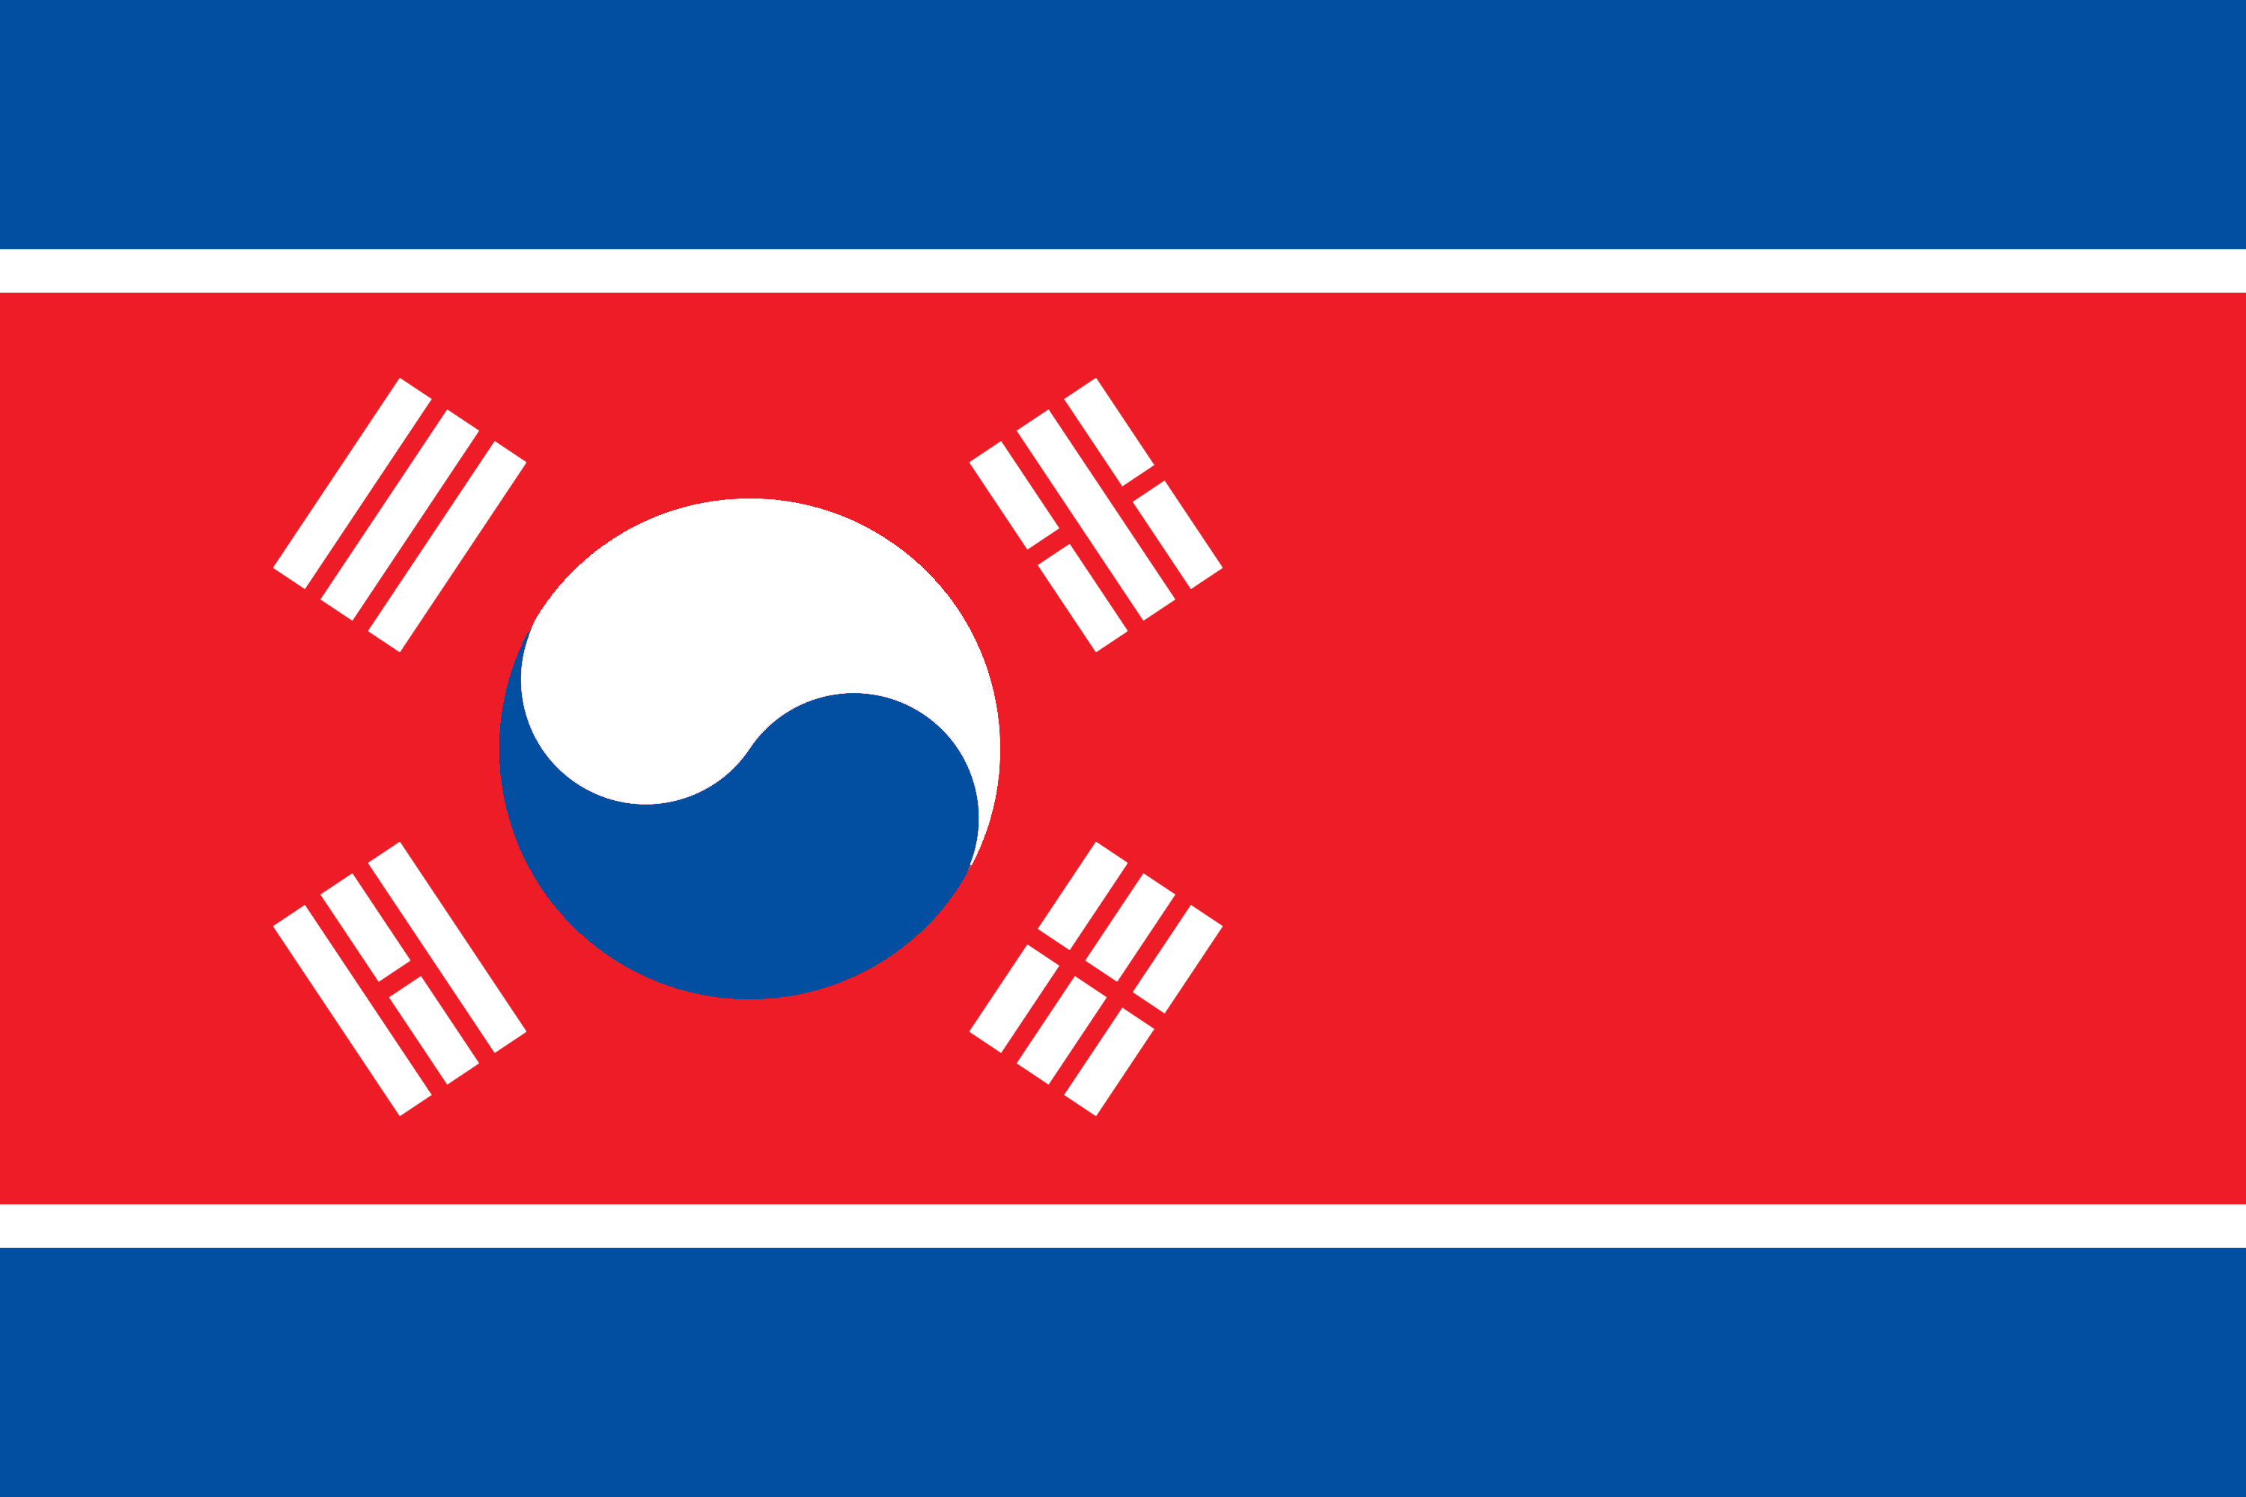
Origin Story
After the explosion that wiped out the connection between northern and southern Ottoman Empire the military quickly seized power in the south. This because they felt that the profits from the trade were kept too much with the rich leaving the poor to rot away. The iron fist of General Barrir now rules the Military Ottoman, not accepting any resistance. However, to the surprise of many the country actually seems to prosper under his rule. The communist regime that has taken over provides jobs and sustenance for all its inhabitants. Despite the many claims by the Ottoman Empire over the area they cannot retake the area making Military Ottoman a sovereign state for over 13 years now.
Economic information
GDP: $1,68 trillion
Main income sources:
- Construction
- Steel
- Foreign aid
Currency: Prijne
Gini coefficient: 0,386
Top trade relations:
- Chinese Empire
- Saharan District
- Communist Republic
Political information
Head of state: General Barrir Hajjar
Legislative power: General Barrir Hajjar
Political orientation: Left wing, communist
Government seat: Cairo
Allies: Ottoman Empire, Saharan District, Congo State
Enemies: North-American Union,
General country information
Name: Military Ottoman
Capital: Cairo
Population: 117.669.404
Area: 3.024.559 km²
Official language(s): Arabic
Demonyms: Arabics
HDI: 0,532

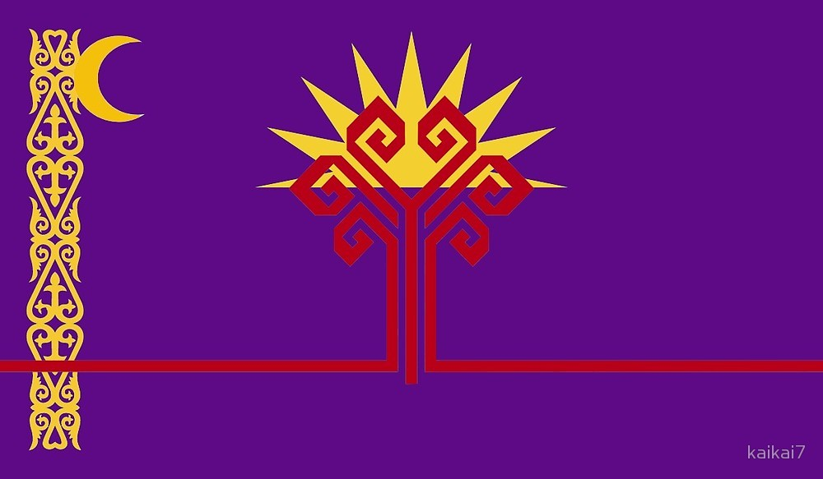
Political information
Head of state: President Matthew Welsh
Political power: Government
Political orientation: Centre-left, capitalist
Government seat: Toronto
Allies: Central Powers, Scandinavian Democracy, British Empire
Enemies: Chinese Empire, Communist Republic, Islamic State
General country information
Name: North-American Union
Capital: Toronto
Population: 527.531.592
Area: 23.956.826 km²
Official language(s): English, French
Denonyms: American
HDI: 0,894

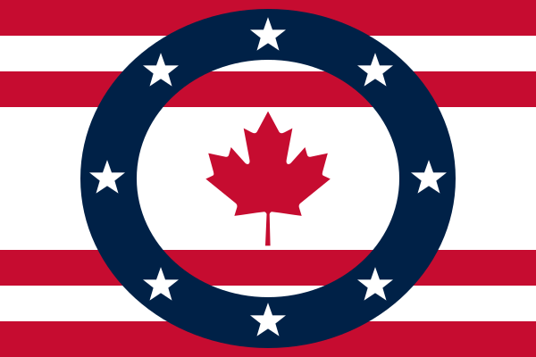
Origin Story
Looking with increasing concern towards the large communistic powers USA was the first to take initiative. They bundled their powers with Canada and traded Greenland for military support with the Scandinavian Democracy if such an occasion should arise. Now they are the largest threat to the communistic regimes and most likely the only thing that keeps them at bay. The North-American Union is about the largest food supplier. Especially the maple syrup that because of its long shelf life and high sugar contains is a much-needed product in the countries that do not have a lot of food. They are also the largest military power, for now.

Economic information
GDP: $30.65 trillion
Main income sources:
- Agriculture
- Manufacturing
- Maple Syrup
Currency: Dollar
Gini coefficient: 0,485
Top trade relations:
- Central Powers
- British Empire
- Scandinavian Democracy

Political information
Head of state: Sultan Imad al Hamal
Legislative power: Sultan Imad al Hamal
Political orientation: Right wing, Capitalist
Government seat: Not applicable
Allies: Saharan District, African Union, British Empire
Enemies: Ticoast Empire, North-American Union, Ottoman Military
General country information
Name: Ottoman Empire
Capital: Istanbul
Population: 146.864.172
Area: 2.686.621 km²
Official language(s): Turkish – Greek
Demonyms: Ottomans
HDI: 0,494

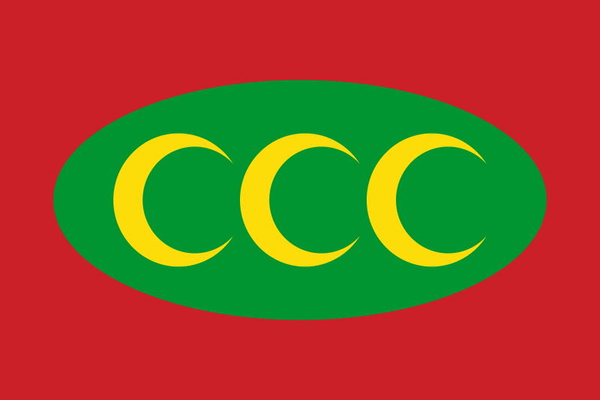
Economic information
GDP: $3,62 trillion
Main income sources:
- Agriculture
- Trade centre
- Mining
Currency: Lira
Gini coefficient: 0,673
Top trade relations:
- African Union
- Saharan District
- Central Powers
Origin Story
Started by Ottoman Empire fanatic Recep Erdogan a widespread belief arose in Turkey that they were robbed of their former territories. Thus, when the Chinese invasion started Turkey invaded on a large scale, whole fully unprepared the other countries brought little resistance. As of right now the Ottoman Empire is a widespread empire reigned solely by a Sultan. They are the general trade centre where countries that do not get along but need each other’s products trade. The Ottoman Empire receives and delivers goods in exchange for a small portion of those goods and works closely together with British Empire both because of the large money flows that surround the Ottoman Empire and because of their shared believes in former glory.

Political information
Head of state: Premier Kareef Aziz
Legislative power: Government
Political orientation: Left wing, capitalist
Government seat: Algiers
Allies: African Union, Ottoman Empire, Islamic State
Enemies: Ticoast Empire, North-American Union
General country information
Name: Saharan District
Capital: Algiers
Population: 107.293.492
Area: 4.632.117 km²
Official language(s): Berber – Arabic – French
Demonyms: Berbers
HDI: 0,694

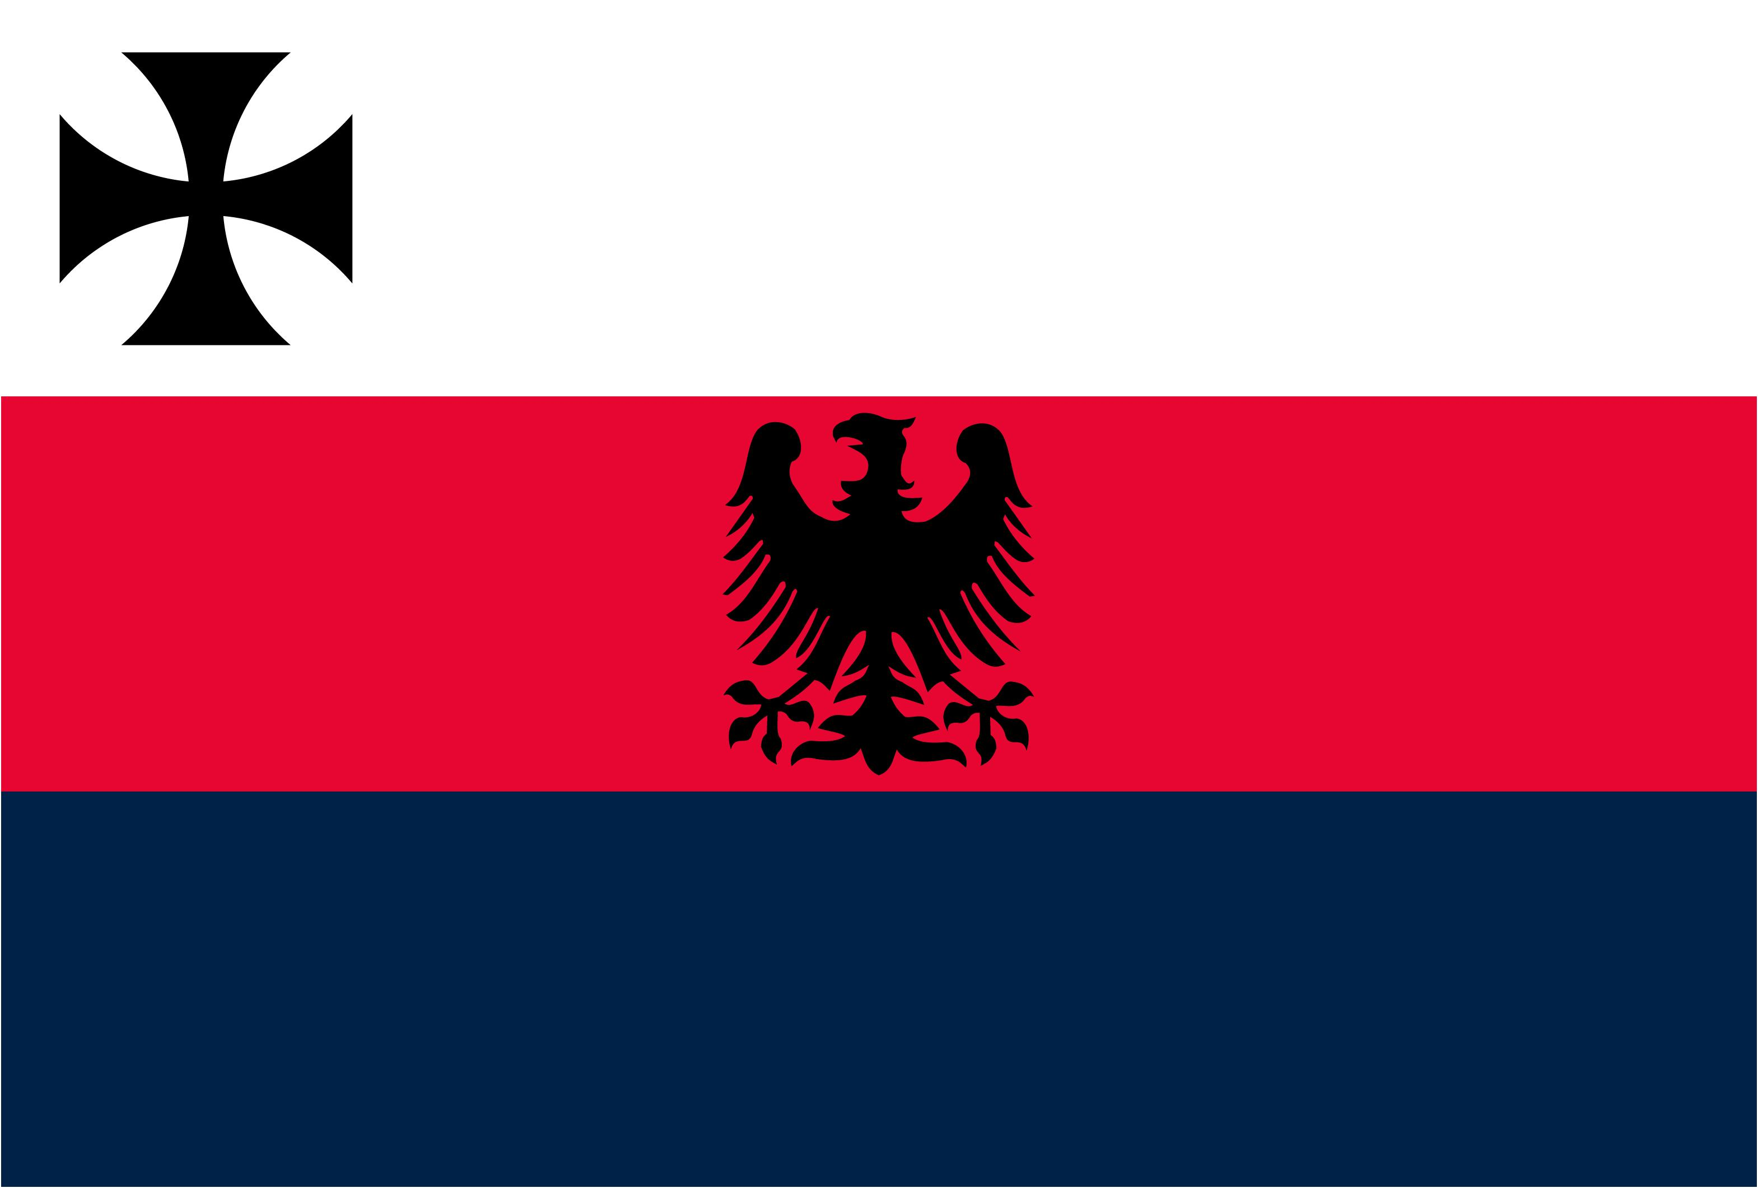
Economic information
GDP: $1,39 trillion
Main income sources:
- Solar Energy
- Thermal Energy
- Uranium
Currency: Tiori
Gini coefficient: 0,512
Top trade relations:
- African Union
- Ottoman Empire
- Central Powers
Origin Story
Seeing the countries around them being conquered the Saharan District found themselves in the unlucky position not to be included in the uniting of countries. Therefore, they decided that they would unite themselves as the outcasts. Right now, they are one of the largest producers of thermal/solar energy using the Sahara as an energy source. Once the oil reserves run out they are the largest provider of energy around the globe. The tradeoff is that the Saharan district deals with severe food shortages. The energy revenue is not evenly distributed and poverty is still around.

Political information
Head of state: Premier Philip Henriksen
Legislative power: Population (through referenda)
Political orientation: Left wing, capitalist
Government seat: Stockholm
Allies: Central Powers, North-American Union, Southern Islands
Enemies: -
General country information
Name: Scandinavian Democracy
Capital: Stockholm
Population: 39.293.032
Area: 1.319.634 km²
Official language(s): Scandinavian
Demonyms: Scandinavians
HDI: 0,951

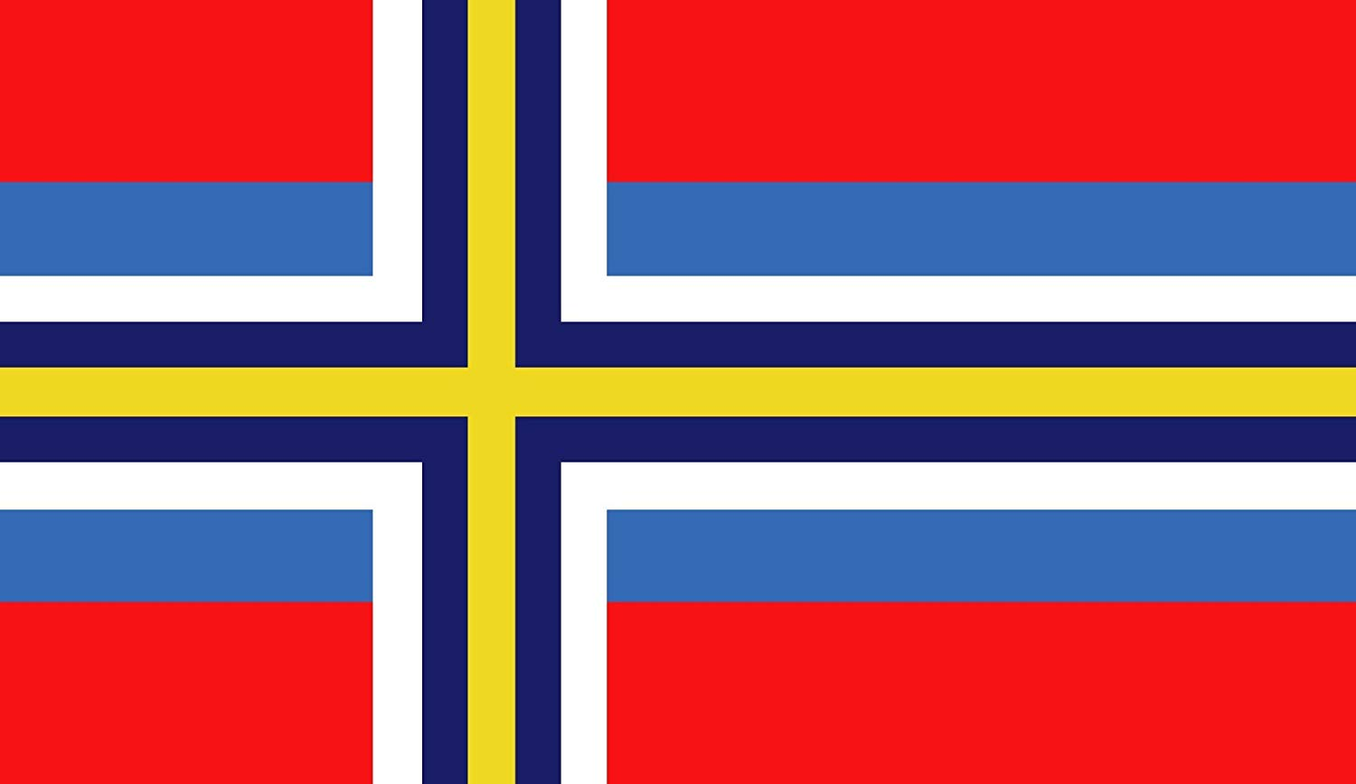
Economic information
GDP: $1.69 trillion
Main income sources:
- Plastic recycling
- Machinery
- Hydropower
Currency: Scandinavian Crown
Gini coefficient: 0,321
Top trade relations:
- Chinese Empire
- Central Powers
- North-American Union
Origin Story
As the world turned to chaos the most logical step was to unite forces with the neighbouring countries. This process went very peacefully. As the Scandinavian countries did not have any enemies before the war, they do not have any enemies now. They are friendly with everyone and have focussed on new and renewable forms of energy, a new way of disposing of trash and much more. The Scandinavian Democracy is focussed on the future and making sure the Earth is still around for the future generations.

Political information
Head of state: Premier Sying Ts’ui
Political power: ASEAN
Political orientation: left wing, capitalist
Government seat: Singapore
Allies: Korean Republic, Central Powers, North-American Union
Enemies: Chinese Empire
General country information
Name: Southern Islands
Capital: Jakarta
Population: 662.727.320
Area: 3.455.461 km²
Official language(s): Indonesian/ Malay, Thai
Demonyms: Islanders
HDI: 0,598

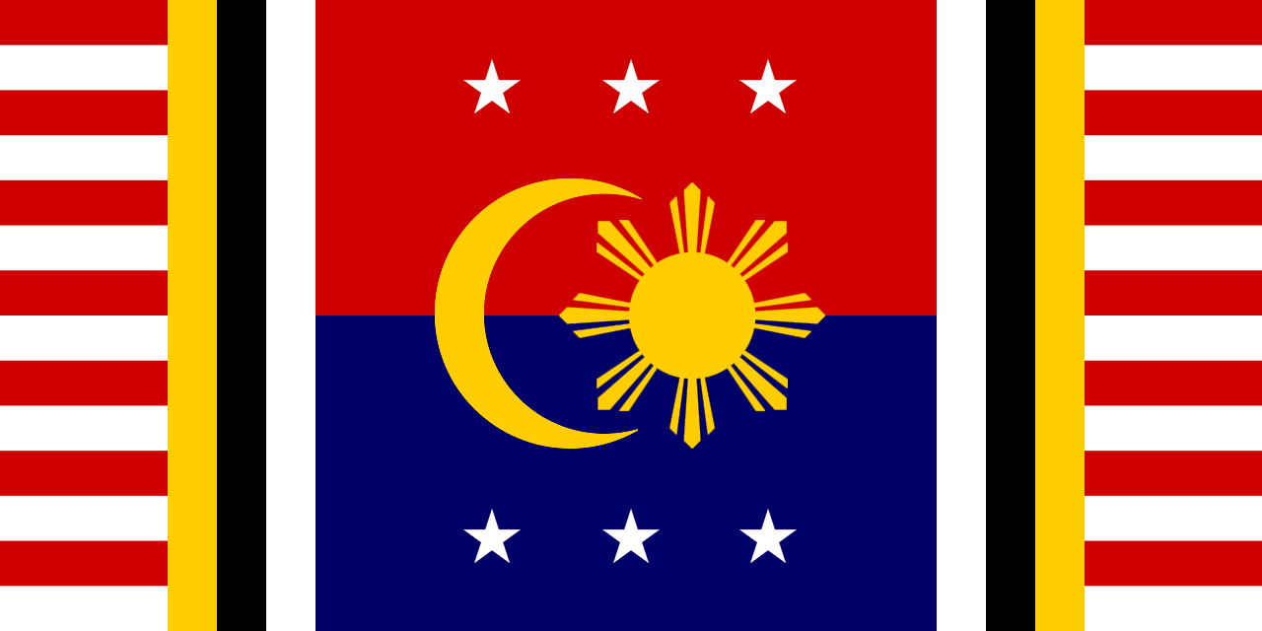
Economic information
GDP: $6,31 trillion
Main income sources:
- Textile
- Coffee
- Palm oil
Currency: Ringgit
Gini coefficient: 0,372
Top trade relations:
- British Empire
- North-American Union
- Ottoman Empire
Origin Story
Seeing their neighbouring countries being conquered the Southern Islands united both politically but especially on military bases. This succeeded as they proved to be too hard to conquer for what the lands had to offer. The Chinese Empire is still knocking on their door but the threat of them actually coming in is reduced to acceptable levels. Large amounts of textile are produced and sold to the Chinese Empire however, the Chinese Empire is using the threat of their military to bring the price of the textile down allowing the Southern Islands to barely hang on. Furthermore they are not allowed to trade with anyone besides the Chinese Empire. Despite the Southern Islands still standing they are under heavy pressure from their much stronger northern neighbour.

Political information
Head of state: Empress Ja’ala Alima
Legislative power: Government
Political orientation: Right-wing, communist
Government seat: Sodo
Allies: Chinese Empire, Communist Republic, Korean Republic
Enemies: North-American Union, Congo State, Central Powers
General country information
Name: Ticoast Empire
Capital: Nairobi
Population: 349.048.203
Area: 6.678.630 km²
Official language(s): Ewachyço
Demonyms: Coastals
HDI: 0,394

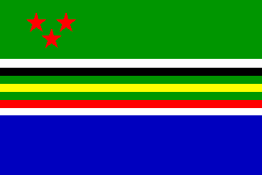
Economic information
GDP: $5,44 trillion
Main income sources:
- Foreign aid
- Mining
- Fishing
Currency: Eprani
Gini coefficient: 0,269
Top trade relations:
- Chinese Empire
- Communist Republic
- African Union
Origin Story
Formerly united because of the Congo threat the Ticoast Empire is now the puppet of the communistic regime. Slowly but surely the Chinese Empire and Communist Republic have made the Ticoast completely depended on them. Now they are nothing more than a war state, having to give everything they produce to the communistic regime in exchange for small amounts of food and large amounts of military support. They are the communist side of the playground and are forced to play a part in the war they themselves did not start.

Political information
Head of state: Prime Minister Donna Quintero
Legislative power: Government
Political orientation: Left wing, capitalist
Government seat: Santiago
Allies: East-Latin Kingdom, Equatorian State, North-American Union
Enemies: Chinese Empire
General country information
Name: West-Latin State
Capital: Santiago
Population: 97.203.439
Area: 2.044.492 km²
Official language(s): Spanish
Demonyms: Latino
HDI: 0,703

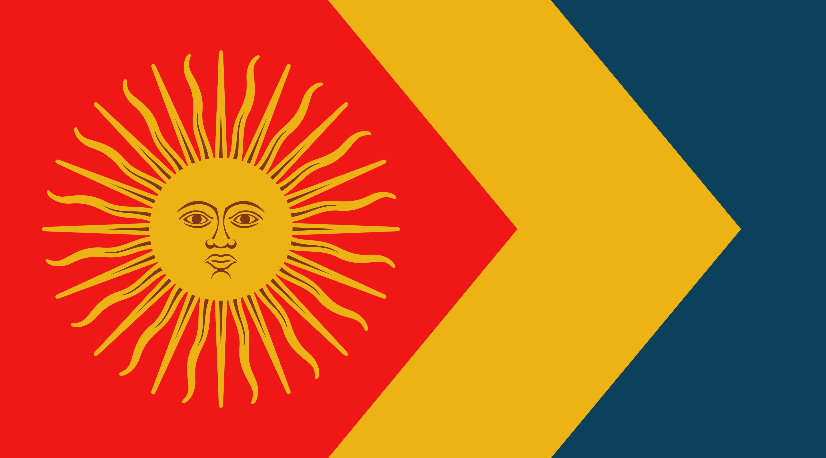
Economic information
GDP: $2.01 trillion
Main income sources:
- Copper
- Textiles
- Fishing
Currency: Krosar
Gini coefficient: 0,488
Top trade relations:
- East-Latin Kingdom
- Equatorian State
- African Union
Origin Story
Struck with fear after the world took such a crazy turn, Brazil started to gather strength from the neighbouring countries. These countries were glad to join the major power that was Brazil. Brazil gave the West-Latin State the opportunity to join their Kingdom; the West-Latin State declined this offer, as they did not want to be ruled by a monarch. The West-Latin State still has great trade relations with the East-Latin Kingdom and the Equatorian State and they are each other’s top trade relations. The West-Latin State also supports the African Union as they have become of great political influence and therefore it is necessary that there is a good relationship between the African Union and the West-Latin State. Today the West-Latin State is focused on maintaining their top trade relations and expending their economic and political power.

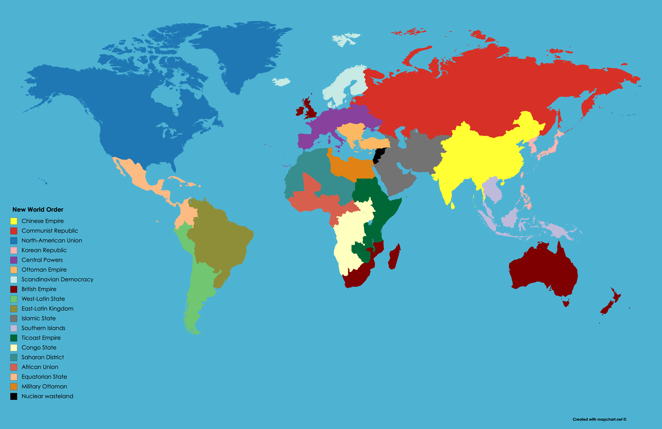

Useful resources:

https://www.mayerbrown.com/en/perspectives-events/publications/2020/05/one-small-step-for-property-rights-in-outer-space#:~:text=Article%20II%20provides%20that%20outer,or%20by%20any%20other%20means%22.

https://www.engadget.com/what-it-will-take-for-humans-to-colonize-the-moon-and-mars-160026478.html?guccounter=1&guce_referrer=aHR0cHM6Ly93d3cuZ29vZ2xlLmNvbS8&guce_referrer_sig=AQAAAJ5KZoGLFXYPvYPZH2ZMP3z1FJy3wRu66P-9kiPjc8UimPi37RD92taa2gJy9tzI-wO2ai379JzZ_PRxmP3_pAxGEJ3J6EpqLaYuB6h7NZBEy5YRLhEnuiMf8KHp3bO--mfE0C141Nap2CIYLKzpTFb5sOzOhhoeDNVqp4sxi1qK

https://www.talksonlaw.com/briefs/who-owns-the-moon

https://www.nasa.gov/centers/hq/library/find/bibliographies/space_colonization

https://www.procon.org/headlines/space-colonization-top-3-pros-and-cons/

Good luck on your research!

