Research Report
General Assembly 2

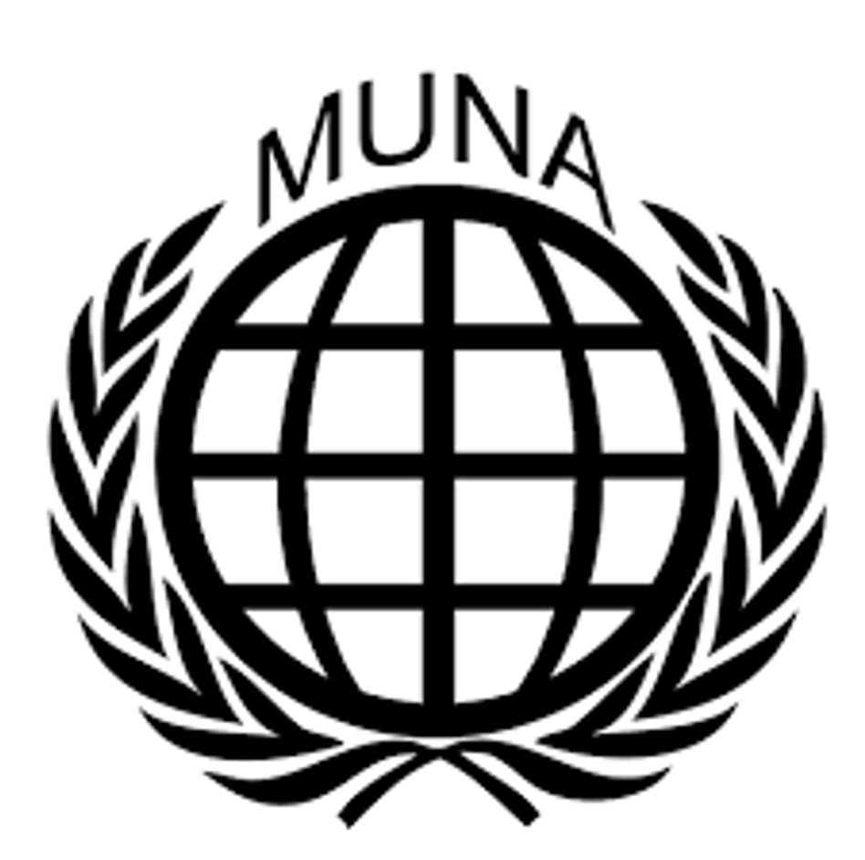The question of how to provide access to quality education for every child.

Student Officers:
Helen Huang and Yasmine Lala
Introduction
The right to education includes the right to learn, yet millions of children worldwide are not achieving basic proficiency in reading and math, even when attending school. Over 600 million children lack these foundational skills, with out-of-school children facing even greater challenges. Barriers to education include poverty, political instability, conflict, natural disasters, disabilities, and discrimination, particularly against girls in some regions.

Even when children attend school, inadequate teacher training, poor materials, insufficient infrastructure, and issues like hunger and exhaustion hinder learning. Additionally, a significant digital divide restricts access to online resources, further limiting educational opportunities.
The lack of quality education has long-term consequences. It makes it harder to get jobs and stay healthy, and limits civic engagement. Without quality education, kids face big obstacles in building better lives and contributing to society.

The pandemic worsened the learning crisis, leaving students in low- and middle-income countries significantly behind in subjects like reading and mathematics. Early childhood education (ECCE) remains neglected in many nations, despite its importance for lifelong learning and emotional well-being. A shortage of qualified teachers, especially in STEM subjects, continues to hinder educational progress, particularly in regions like Sub-Saharan Africa. Additionally, policy decisions often ignore empirical evidence, contributing to ineffective education systems.
Conflict and violence can also disrupt education for children, especially in conflict zones like Sudan and Syria, where attacks on schools and displacement prevent access to learning. On the other hand, wealthier countries face challenges like educational inequality and access to digital tools. Global collaboration is essential to ensure that every child has access to quality education.

The Committee:
General Assembly 2 is a fairly ordinary committee, meaning there are no special Rules of Procedure specific to this committee. In MUNA, General Assembly 2 deals with issues on human rights, which can include an immense number of topics. In this General Assembly, nations come together to discuss one’s (individual) rights and find solutions in a peaceful and respectful manner.
When debating on different solutions, it is important to note money is not an issue as nations can call upon the UN’s unlimited funds. Hence, a delegate should never vote or speak against a resolution because of financial reasons.

An important fact to note is that the real Second Committee deals with economic and financial issues and that the Human Rights Council would actually discuss the issues we do in this committee. Due to restrictions in space, human rights are being dealt with in General Assembly 2.

Keywords:
Education - The process of learning, or the acquisition of knowledge, skills, values, beliefs, and habits through teaching, training and research
Inequality - The unequal distribution of resources, opportunities, and treatment. It often refers to disparities based on factors like gender, ethnicity, geographical location or socioeconomic status
Access to education - The ability and chance of individuals to obtain and benefit from educational opportunities, which can be influenced by social, financial, systemic, and geographic factors
Quality education - Education that is equitable and inclusive, providing the learners with the necessary knowledge and skills to thrive socially, economically and personally
Covid-19 - A global pandemic, which significantly disrupted the worldwide education, leading to the closure of schools, loss of learning, and broadened inequalities
SDG 4 - Sustainable Development Goal 4: A United Nations initiative to ensure equitable and inclusive quality education and promote lifelong learning opportunities for all by 2030.

Arguments:
Access to quality education is a fundamental right, and essential to break cycles of poverty and to foster sustainable development. Some argue that international efforts like increasing funding for education infrastructure, or investing in teacher training, would ensure equitable access. They emphasize that addressing social barriers like gender, poverty, and discrimination is essential to achieve the SDG 4.

However, others argue that focusing mainly on access without addressing quality can lead to mediocre learning outcomes. They stress that reforms should tackle the root issues, like poverty, while ensuring that interventions are culturally relevant. Balancing access with quality and equity is essential to create sustainable, effective solutions.

Timeline:
2000 – Millennium Development Goals (MDGs) set by 189 UN member states. Goal 2 aimed to achieve universal primary education by 2015.
2015 – sustainable development goals (SGDs) adopted by the United Nations. SDG 4 aimed to ensure inclusive and equitable quality education for all by 2030.
2020-2022 – COVID-19 pandemic caused widespread school closures
Resolution:
When composing a resolution, a delegate should carefully consider their country’s perspective and opinion on the matter. This research report is a good starting point for your research. Try to think of ways that offer a solution for all countries involved to protect cultural diversity of national, ethnic, religious, and linguistic minorities. Remember to focus on all nations in the world keeping in mind the different crises in the world and the effects people all over the world experience from them. Make sure the measurements are realistic and achievable.
Moreover, you should keep in mind that different countries have different policies and keep the global differences in mind. These differences might be economic; however, they are also largely cultural. Make sure to research your country in detail, and keep in mind that you are speaking as if representing that nation. Therefore, make sure to have done some research about your country’s policies before joining the conference.

Useful sites:
- https://www.unicef.org/education
- https://www.concern.net/news/problems-with-education-around-the-world
- https://blogs.worldbank.org/en/education/four-biggest-problems-facing-education-and-four-trends-could-make-difference
- https://www.mdgmonitor.org/millennium-development-goals/#:~:text=MDG%202%3A%20Achieve%20universal%20primary%20education&text=There%20is%20only%20one%20target,of%20primary%20education%20by%202015.
- https://education.ec.europa.eu/news/report-covid-impact-learning-outcomes
- https://www.undp.org/sustainable-development-goals

