Research Report
General Assembly 2

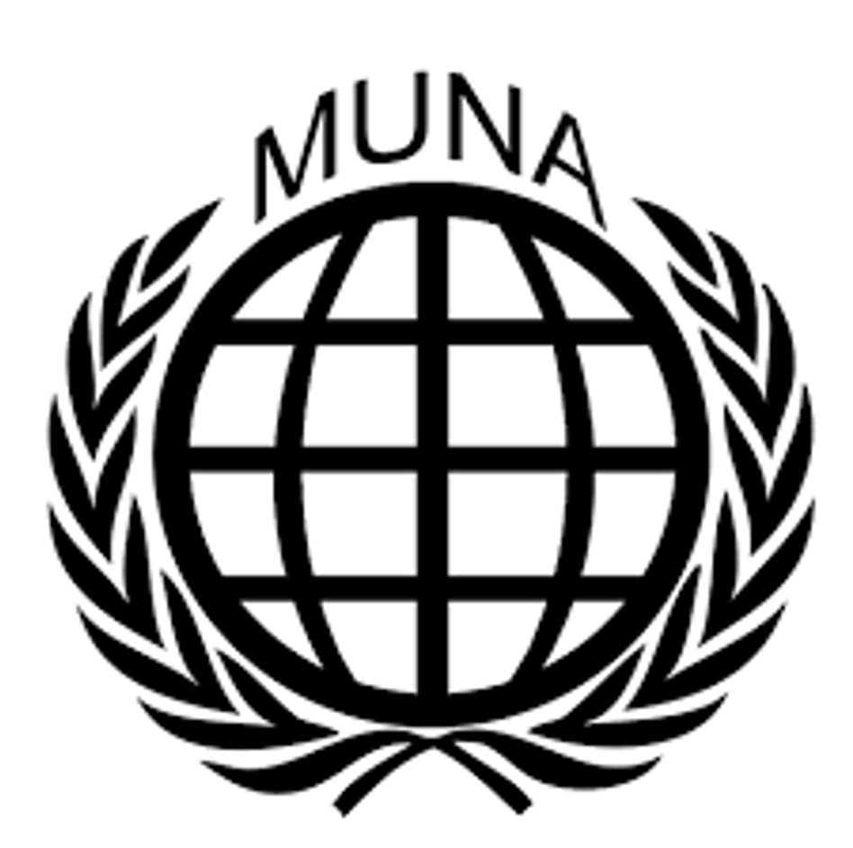Combatting the use of violence against civilians in DR Congo

Student Officers:
Helen Huang and Yasmine Lala

Introduction:
The Democratic Republic of Congo is currently facing one of the most tenacious and severe humanitarian crises world-wide, with millions of civilians suffering from violence, by armed groups and government forces. Civilians are often targeted through sexual violence, enforced displacement and mass killings, leading to disastrous human rights violations and an astounding displacement of over seven million people, from which most are innocent.

Despite the international presence of organisations seeking to stabilize, armed groups like the M23 and the ADF continue their attacks on civilians. The military force of the DRC lacks coordination and planning, which is aggravating the situation, as well as the presence of international peacekeepers. Diplomatic efforts to address these issues are not sufficient. It is of the essence to address the systemic failures to protect the lives of millions, and securing long-term peace in the region of the DRC.

The underlying causes of violence, which include competition for natural resources, ethnic tensions and regional rivalries, further complicate efforts for peace. Neighboring countries like Rwanda have been accused of backing groups like M23, which shows the issue is not only limited to the DRC. The Congolese government must improve its governance, and ensure that military operations do not harm civilians.Combating violence against civilians requires a many-sided approach, balancing regional cooperation, humanitarian aid, and enhanced international support to dismantle armed groups, while simultaneously protecting vulnerable civilians.

The Committee:
General Assembly 2 is a fairly ordinary committee, meaning there are no special Rules of Procedure specific to this committee. In MUNA, General Assembly 2 deals with issues on human rights, which can include an immense number of topics. In this General Assembly, nations come together to discuss one’s (individual) rights and find solutions in a peaceful and respectful manner.
When debating on different solutions, it is important to note money is not an issue as nations can call upon the UN’s unlimited funds. Hence, a delegate should never vote or speak against a resolution because of financial reasons. An important fact to note is that the real Second Committee deals with economic and financial issues and that the Human Rights Council would actually discuss the issues we do in this committee. Due to restrictions in space, human rights are being dealt with in General Assembly 2.

Keywords:
Armed groups - Militias such as the ADF and M23, which are the primary perpetrators of violence against civilians
ADF - The Allied Democratic Forces, a militia group in Uganda and the DRC. The USA and Uganda recognize it as a terrorist group
M23 - The March 23 movement, which is also known as the Congolese Revolutionary Army is a militia group in the DRC. They have been accused of abusing human rights by the Human Rights Watch
Displacement - The situation in which people are forced to leave the place where they normally live. Over seven million people have been displaced in the DRC.
Ethnic tensions - Long standing ethnic rivalries, which contribute to cycles of violence and attacks of civilians

Arguments:
Violence against civilians in the DRC is a many-sided issue. Advocates for international action argue that it is a moral and legal imperative to protect civilians under international human rights laws, such as the Universal Declaration of Human Rights. They argue that international peacekeeping and regional diplomacy must be strengthened to prevent the atrocities happening, and to stabilize the region.
However, others may argue that the current interventions lack coordination, which may aggravate the situation. Others may argue that the focus should not only be on military solutions, because it leads to the neglect of root issues like ethnic tensions. It is critical to balance immediate protection of civilians with long-term solutions like governance reform, or even economic equity.

Timeline of events:
1996 - 1997 - The First Congo War. This marked the beginning of conflict in the region.
1998 - 2003 - The Second Congo War. This conflict involved multiple countries, and led to continued violence against civilians.
2012 - 2013 - The M23 rebellion. M23 captured Goma, and committed many violations to human rights.
2022 - M23 activity increases after years of silence. Accusations of Rwandan support for the group led to heightened tensions in the region.

Resolution:
When composing a resolution, a delegate should carefully consider their country’s perspective and opinion on the matter. This research report is a good starting point for your research. Try to think of ways that offer a solution for all countries involved to protect cultural diversity of national, ethnic, religious, and linguistic minorities. Remember to focus on all nations in the world keeping in mind the different crises in the world and the effects people all over the world experience from them. Make sure the measurements are realistic and achievable.
Moreover, you should keep in mind that different countries have different policies and keep the global differences in mind. These differences might be economic; however, they are also largely cultural. Make sure to research your country in detail, and keep in mind that you are speaking as if representing that nation. Therefore, make sure to have done some research about your country’s policies before joining the conference.

Useful sites:
- https://www.amnesty.org/en/location/africa/east-africa-the-horn-and-great-lakes/democratic-republic-of-the-congo/report-democratic-republic-of-the-congo/
- https://www.nrc.no/perspectives/2024/whats-happening-in-the-democratic-republic-of-the-congo/
- https://reliefweb.int/report/democratic-republic-congo/conflict-dr-congo-whats-happening-how-help
- https://www.cfr.org/global-conflict-tracker/conflict/violence-democratic-republic-congo
- https://www.aljazeera.com/news/2024/2/21/a-guide-to-the-decades-long-conflict-in-dr-congo
- https://www.amnesty.org/en/latest/campaigns/2024/10/why-is-the-democratic-republic-of-congo-wracked-by-conflict/
- https://www.worldbank.org/en/country/drc/overview
- https://reporting.unhcr.org/operational/situations/democratic-republic-congo-situation

