Research Report
General Assembly 2

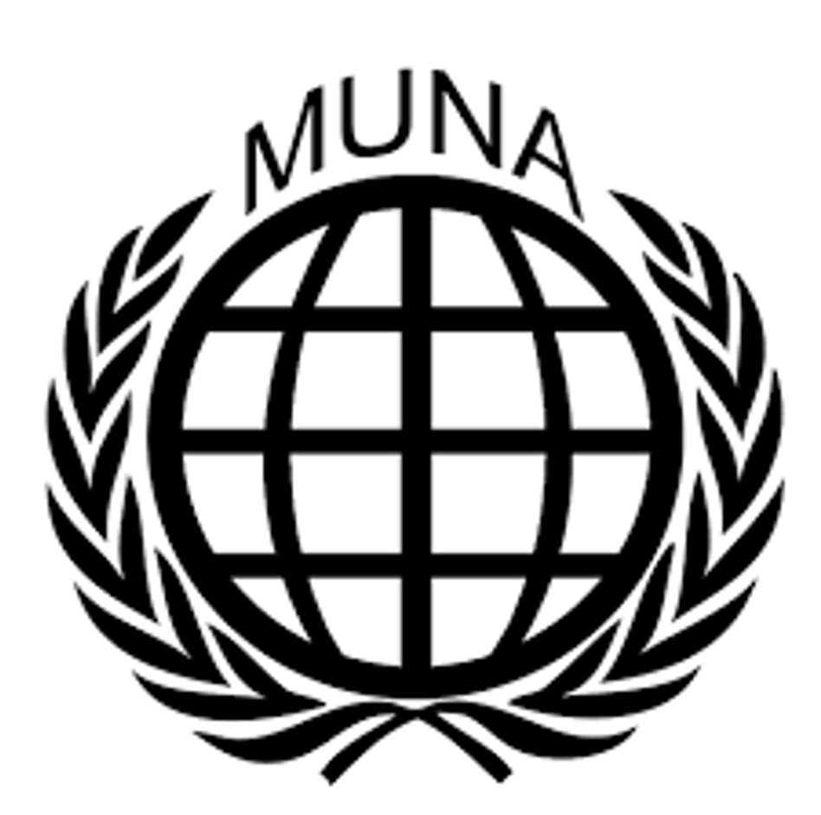Engaging in discussion with countries that use child soldiers

Student Officers:
Helen Huang and Yasmine Lala

Introduction:
A child soldier is defined as anyone under the age of 18, who is recruited with force to participate in armed conflicts. Child soldiers are often children who struggle due to factors like poverty, hunger, a lack of education, and violent mistreatment, which makes them susceptible to recruitment of armed groups. These armed groups violate human rights by recruiting anyone under the age of 18.
The children are not only used as fighters, but also as spies, cooks, porters and even for sexual purposes. The recruitment of children as soldiers leaves them not only with the same trauma as adult soldiers, but also with the loss of their childhood and innocence.

The international community has taken steps to address and solve this issue. The most notable effort came from the UN, which has adopted the ’Optional Protocol on the Involvement of Children in Armed Conflict’', which states that children under 18 are not allowed to be soldiers, and that states should prevent and demobilize child soldiers, as well as provide victims psychosocial support. This protocol has been entered into force in 2002, and has been adopted by most of the countries.
Despite this, the enforcement of the OPAC remains inconsistent. There are still tens of thousands children that are being recruited to this day in armed conflicts. The CSPA list of 2022 shows that there are 12 countries, in which children are still exploited as soldiers.

The perseverance of the recruitment of children is a grave violation of human rights, and aggravates the instability in regions containing armed conflict. The use of child soldiers strengthens armed groups, which threatens security and peace. It is essential to address this issue to uphold the rights of children, as well as to keep the peace in areas in which there is an armed conflict.

The Committee
General Assembly 2 is a fairly ordinary committee, meaning there are no special Rules of Procedure specific to this committee. In MUNA, General Assembly 2 deals with issues on human rights, which can include an immense number of topics. In this General Assembly, nations come together to discuss one’s (individual) rights and find solutions in a peaceful and respectful manner.
When debating on different solutions, it is important to note money is not an issue as nations can call upon the UN’s unlimited funds. Hence, a delegate should never vote or speak against a resolution because of financial reasons.

An important fact to note is that the real Second Committee deals with economic and financial issues and that the Human Rights Council would actually discuss the issues we do in this committee. Due to restrictions in space, human rights are being dealt with in General Assembly 2.

Keywords
IHRL: International Human Rights Law
IHL: International Humanitarian Law
CRC: Crisis Response Centre, the single entry-point for all crisis-related matters within the EEAS: (The European External Action Service), providing a 24/7 permanent crisis response capability to address emergencies that endanger the safety of staff in EU Delegations or involve crises impacting EU citizens abroad.
OPAC: Optional Protocol on the Involvement of Children in Armed Conflict
UN: United Nations
CSPA: Child Soldiers Prevention Act

Arguments
Member states should keep in mind the International Human Rights Law (IHRL) and International Humanitarian Law (IHL), as well as the CRC’s article 38. Additionally, it is important to recognize that children perform various tasks besides fighting. The Operational Protocol of the CRC (2000) raised the age of recruitment to 18 years old under article 1 and protects children who are recruited by state and non-state armed forces under article 4. However, there is a lack of protection from voluntary recruitment and the Protocol only has 52 signatories, meaning that it is not binding on all states.

Child soldiers are often seen as victims, however, some argue they should have some level of accountability, as they also act as perpetrators on the battlefield. Nonetheless, from a human rights perspective, it is challenging to regard them as perpetrators and be subject to judgment. The Sierra Leone Truth and Reconciliation Commission, in its 2004 final report, highlighted that the violence by child soldiers was often a means to gain respect from captors and ensure their own safety; for many it was a choice for survival. Similarly, voluntary recruitment is rarely truly voluntary. The environments in which the children live often push them to join armed groups for survival. Factors such as the lack of access to education, extreme poverty, limited livelihood opportunities, and the desire to protect their families or communities make children vulnerable to recruitment.

Timeline of events
2000 → The OPAC is adopted by the UN General Assembly.

12 February 2002 → The OPAC came into force

2005 → The UN Security Council passed resolution 1612, which condemns the recruitment and use of child soldiers by parties in armed conflict.

2022 - Now → Tens of thousands of children are still being recruited as child soldiers in armed conflicts, in countries such as the DRC, Syria and many more.

Resolution
When composing a resolution, a delegate should carefully consider their country’s perspective and opinion on the matter. This research report is a good starting point for your research. Try to think of ways that offer a solution for all countries involved to protect cultural diversity of national, ethnic, religious, and linguistic minorities. Remember to focus on all nations in the world keeping in mind the different crises in the world and the effects people all over the world experience from them. Make sure the measurements are realistic and achievable.
Moreover, you should keep in mind that different countries have different policies and keep the global differences in mind. These differences might be economic; however, they are also largely cultural. Make sure to research your country in detail, and keep in mind that you are speaking as if representing that nation. Therefore, make sure to have done some research about your country’s policies before joining the conference.

