Research Report
General Assembly 3
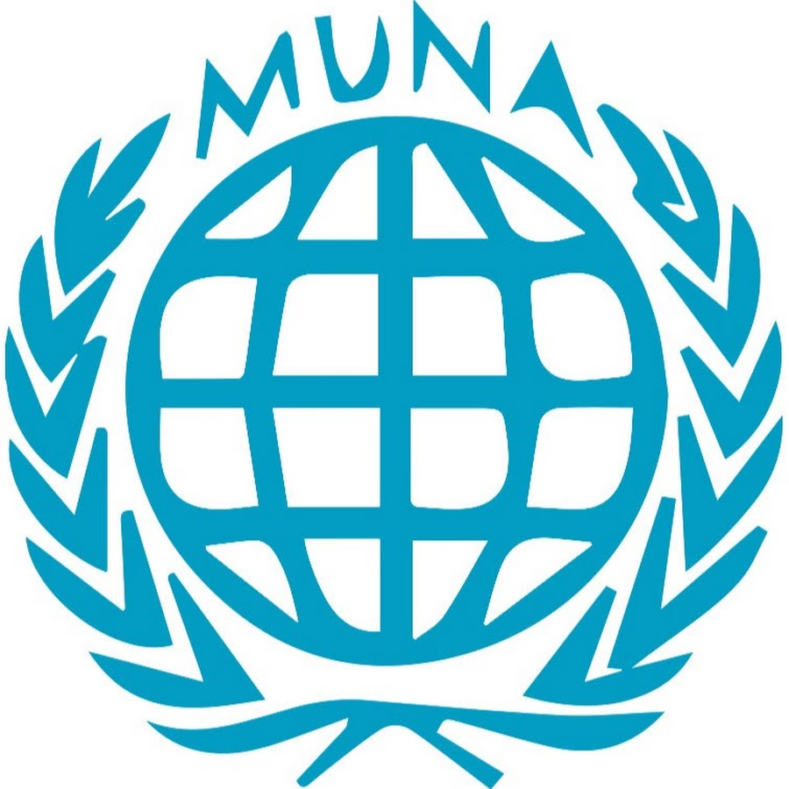
Enhancing public health infrastructure in Sub-Saharan Africa to better combat diseases.

Student Officers:
Mansimran Kaur and David Brenici
Introduction

The health infrastructure throughout all regions of the world forms the base of our healthcare as it is today. It consists of medical facilities, medical systems and services, but also training systems. By maintaining high standards in healthcare and keeping up to modern technologies, all people worldwide should get proper healthcare and medical supplies.

However, not all countries have an optimal healthcare infrastructure which is accessible for the people; healthcare is lacking behind in terms of quality and development in certain countries, which leads to the spreading of diseases, higher mortality rates and inequality within healthcare in both the social and economic systems of the country. Countries in Africa, and most frequently Sub-Saharan Africa, deal with these issues the most, due to poverty, conflict or insufficient nourishment. Therefore many organizations are involved into aiding countries’ health infrastructure, with the main organizations in (Sub-Saharan) Africa being the WHO, bringing leadership on policies and technical knowledge/resources against health issues, Africa CDC, which controls and surveils diseases to prevent them from breaking out such as Ebola and recently COVID-19, and NGOs such as Médecins sans Frontières (Doctors Without Borders), Save the Children and The Red Cross offering medical care and services for all people in the region.

The Committee

General Assembly 3 is one of the General Assemblies and does not have any special procedures assigned to the committee. General Assembly 3 in MUNA deals with environmental, humanitarian and health issues. In General Assembly 3 nations can debate about environmental, humanitarian and health issues, with the aim to raise awareness and resolve the issues in question.
Whilst debating about an issue in MUNA, financial factors are never a problem. Please consider that there are no financial constraints and do not vote or speak against resolutions due to financial reasons.

Keywords

WHO: World Health Organization, the main global authority under the United Nations when it comes to international health matters.

Africa CDC: African Centres for Disease Control and Prevention, the main health institution in Africa that monitors and controls diseases in Africa to prevent them from breaking out, such as Ebola and more recently COVID-19.
NGOs: Non-Governmental Organizations, non-profit organizations that have no association with any political institution.

The Scramble for Africa: European conquest and colonization of Africa that lasted from 1885 until 1914, but still caused for implications after.

UNICEF: United Nations International Children’s Emergency Fund, part of the UN as goal to protect children’s rights.

USAID: United States Agency for International Development, sends aid to third-world countries from the United States.

Overview

To fully understand the situation in Sub-Saharan Africa, it is important to know some background information of the history of the region, the important events that have taken place and the current developments in terms of public healthcare infrastructure.

- (1870s-1950s) Colonization of African countries and The Scramble for Africa.
During the times of the Antiquity, European countries began to exploit the African region to their own advantage by colonizing them. Colonization has completely disrupted the African economies and thus the countries’ own ruling system, which ultimately results in bad management of healthcare, together with the fact that they lacked funds and relied heavily on European goods and supplies. Furthermore, by colonizing these countries, European countries brought their language, culture but also their strict and ruling policies with them. This therefore could also affect the healthcare infrastructure in the region. Most notable countries involved in the colonization of Africa at that time were the United Kingdom, France, Germany, Belgium, Italy, Portugal and Spain.

- (1960s-now) (Civil) wars within the regions between government/religion.
After the colonization efforts from Europe, Africa now had several independent, sovereign states that have their own government, follow their own policies and practice their own faith. However, due to the exploitation that took place Africa was now plundered, poor and amongst the lowest-developed nations in the world, especially in Sub-Saharan Africa. Not only the exploitation caused for bad national structures, but there were also countries on the rise with different religions and different (types of) governments that often collided with country’s population’s needs. Civil wars between ethnic groups broke out, which blocked a nation’s development and outside support, which also destroyed demographics in African countries and leave out the importance of healthcare in Africa.

- (to this day) Outbreaks of diseases, especially in conflicted, African regions.
Every year reports out of health organizations within Africa and worldwide come out displaying reported cases of disease that originate from Africa due to the bad humanitarian conditions in the region. An example, Monkeypox, has been discovered for the first time in the conflicted nation of Democratic Republic of Congo, in 1970. Since then, the disease had an outbreak throughout Africa and eventually globally. Even recently, in 2024, cases have been confirmed outside of Africa and even came close to becoming a global health crisis again. Another well-known widespread disease is Ebola and has killed over 15.000 people since 1976.

Arguments

International organizations have emphasized the fact that healthcare in Sub-Saharan Africa is poor and way below average. Humanitarian aid is vital to the region to keep disease out of bay and resist upon healthcare in the region, however, often a country is affected by conflict or has governmental restrictions which blocks UN aid from entering. Ensuring that enough aid is brought to all nations in question is crucial to sustain a functioning healthcare infrastructure in Sub-Saharan Africa and prevent diseases to break out and spread further.

The United States, United Kingdom, the member states of the European Union and China have collectively made an effort to support the African nations by sending (medical) supplies, services and financial aid. China in particular has made their influence in African health structures increasingly bigger over the past century. However, certain governments have imposed an increased censorship within their country limiting engagement in medical aid.

Timeline of events

There are several key moments when major healthcare infrastructure developments have been sent to Africa. They consist of (but not limited to):

- 1977: WHO publishes the first list of essential medicines for global health conditions.
- 1978: The WHO and UNICEF wrote an all-important declaration that identified primary health care as the key to the attainment of the goal of global health.
- 1990: The first United Nations Development Programme’s Human Development report came out, changing the focus of development initiatives to people-centered policies
- 2002: A new Global Fund made it possible for 36 African countries to receive grants to fight AIDS, Tuberculosis and Malaria.
- 2014: The first cases of Ebola have been reported in Guinea, Africa and marks the beginning of the West Africa Ebola epidemic, the largest in history.
- 2017: Africa CDC has been initiated to support public health services.
- 2020: USAID commences Health Systems for Tuberculosis (HS4TB), HS4TB will continue supporting 23 countries’ efforts to strengthen health financing and governance of Tuberculosis programs

Resolution

A delegate should carefully consider their country's perspective and opinion on the matter when writing a resolution. This research report is a good starting point for your investigation. Consider ways to debate on the independence of the non-self-governing territories that benefit the most countries involved. Remember to pay attention not only to the less-developed countries involved in the issue, but also to the developed countries. Goals should be realistic and attainable. Furthermore, keep in mind that different countries have different policies, as well as global differences. These differences may be economic, but they are also primarily cultural. Make sure to thoroughly research your country and remember that you are speaking as if you are representing that country. Therefore, before attending the conference, do some research on your country's policies.
For more information on resolution writing, please refer to the MUNA booklet on our MUNA site: https://munalfrink.nl/.

Links and Sources

https://www.igi-global.com/dictionary/beyond-digital-tools/72869
https://www.sciencedirect.com/topics/social-sciences/health-infrastructure
https://www.who.int/news/item/05-07-2018-low-quality-healthcare-is-increasing-the-burden-of-illness-and-health-costs-globally
https://www.afro.who.int/
https://gh.bmj.com/content/7/Suppl_1/e008317
https://www.who.int/news/item/13-12-2017-world-bank-and-who-half-the-world-lacks-access-to-essential-health-services-100-million-still-pushed-into-extreme-poverty-because-of-health-expenses
https://www.eea.europa.eu/help/glossary/chm-biodiversity/non-governmental-organization-ngo
https://academic.oup.com/book/871/chapter/135470488#:~:text=The%20period%20of%20colonial%20rule,this%20period%20shaped%20African%20history
https://www.tralac.org/images/News/Documents/Analysis_of_Colonialism_and_Its_Impact_in_Africa_Ocheni_and_Nwankwo_CSCanada_2012.pdf
https://en.wikipedia.org/wiki/Military_history_of_Africa
https://africacdc.org/disease-outbreak/
https://www.un.org/africarenewal/magazine/issue/main-donor-countries-have-declared-africas-new-development-programme-bold-and-clear
https://www.who.int/news/item/27-08-2024-fourteen-african-countries--key-partners-unite-to-provide-critical-resources-for-health-in-who-s-first-ever-investment-round
https://pmc.ncbi.nlm.nih.gov/articles/PMC4073246/
https://msh.org/timeline/

